The Impact of Three Distinct Exercise Methods HIIT, HIT, and MIT on the Expression Levels of JNK and ERK Genes in Male Wistar Rats’ Liver Tissue
Short title: JNK and ERK Levels in Liver Tissue after exercise
Reyhane Azhdari¹*, Saeed Naghibi¹, Majid Gholipour¹
- Department of Exercise Physiology, Payame Noor University, Tehran, Iran
- Department of Physical Education, Sharif University of Technology, Tehran, Iran
*Corresponding author: reyhaneajdari@gmail.com
Abstract
Background: Preventing apoptosis plays a critical role in human physiological adaptations. This study examined the impacts of various aerobic exercise intensities on liver tissue and the expression of JNK and ERK genes.
Methods: 32 male Wistar rats, two months old and weighing approximately 237 ± 33 grams, underwent an 8-week aerobic training program, which included moderate-intensity training (MIT), high-intensity interval training (HIIT), and high-intensity training (HIT). Post-training, the rats were anesthetized, and blood and liver tissue samples were collected. Gene expression levels were determined using RT-PCR and analyzed via the 2-ΔΔCt method. Data were processed using SPSS (version 22).
Results: After 8 weeks, no significant differences in JNK gene expression were found between the control and exercise groups (MIT, HIT, HIIT) (P > 0.05). However, HIT and HIIT led to increased gene expression, with HIIT showing the most significant rise (P = 0.015 and P < 0.001, respectively).
Conclusion: Higher-intensity exercise, especially HIIT, may enhance recovery from liver tissue injury by significantly upregulating JNK and ERK gene expression. These findings suggest that intense aerobic exercise can promote physiological adaptations and support tissue regeneration.
Keywords: Aerobic Exercise, Exercise Therapy, Extracellular Signal-Regulated Kinase, JNK Mitogen-Activated Protein Kinases.

Introduction
Exposure to factors such as environmental contaminants, poor diet, and chemotherapy accelerates apoptosis, often causing the activation of the mitogen-activated protein kinase (MAPK) signaling pathway (1). Apoptosis, driven by genetic changes, is regulated by three major MAPK subfamilies: extracellular signal-regulated kinases (ERKs), c-Jun N-terminal kinases (JNKs), and p38 mitogen-activated protein kinase (p38MAPK) (2). While ERKs typically promote cell proliferation, JNKs and p38MAPK are primarily associated with cellular stress responses that culminate in apoptosis (3). However, ERKs may also induce apoptosis in specific conditions, such as hypoxia-induced apoptosis in macrophages and cisplatin-induced apoptosis in HeLa cells (4, 5).
Epidemiological studies have revealed a significant correlation between physical exercise and reduced apoptosis, but controlled experimental studies are required to understand the molecular mechanisms underpinning this relationship (6, 7). Animal models, such as rats, are essential for uncovering the molecular pathways by which exercise influences apoptosis, offering more direct insights than human studies (8).
Previous research has explored the impact of aerobic exercise on apoptosis in various tissues. For instance, Ghahremani et al. (2018) studied the impact of aerobic exercise intensity on apoptosis in rats with myocardial infarction, showing that exercise reduced cardiomyocyte apoptosis through the regulation of BAX and B-cell lymphoma 2 (Bcl-2) protein expression. The study found that exercise intensity played a critical role, with low-intensity interval training (LIIT) proving more effective for cardiac rehabilitation than high-intensity interval training (HIIT) (9). Similarly, Lu et al. compared the effects of HIIT and endurance training on apoptotic markers in female rats, finding that both training types significantly reduced apoptosis by affecting proteins such as AMP-activated protein kinase (AMPK), protein kinase B (AKT), phosphoinositide 3-kinase (PI3K), and p38MAPK (10). Parco’s research, focused on eight weeks of low-intensity exercise, reported increased levels of anti-apoptotic proteins Bcl-2 and HSP70, decreased pro-apoptotic proteins Bax and APAF-1, and no significant changes in caspase-3 (11). Phaneuf et al. also demonstrated a reduction in apoptosis immediately after an aerobic exercise session (12).
With the growing recognition of exercise as a therapeutic approach to managing liver diseases, this research investigates the impact of three distinct exercise regimens—HIIT, high-intensity training (HIT), and moderate-intensity training (MIT) on the expression of JNK and ERK genes in the liver tissue of male Wistar rats. This research aims to expand understanding of how exercise intensity influences apoptosis-related pathways in liver tissue, with potential implications for treatment strategies targeting liver injury and disease.
Materials and Methods
Materials
The materials were used in this research included TRIzol reagent (Sigma, Poole, UK), SYBR Green PCR Ace Blend (Invitrogen, Paisley, UK), and the cDNA Union Pack (Invitrogen, Paisley, UK).
Animals
This study involved 32 male Wistar rats, aged 8 weeks, with an average body mass of 237 ± 33 g. The rats were obtained from the Razi Institute and housed in polycarbonate cages, with eight rats per group. The housing conditions were maintained at a temperature of 22 ± 1.4 °C, 55 ± 4% humidity, and a 12-hour day-night cycle. The rats’ weights were recorded at the start, at the end of the study, and before dissection.
The rats were randomly split into four groups:
- Control Group: Rats in this group did not undergo formal exercise but were mounted on a stationary treadmill for 10–15 minutes, five days a week, to acclimate to the environment.
- MIT Group: This group followed a moderate-intensity training (MIT) protocol for 8 weeks.
- HIT Group: These rats underwent a high-intensity training (HIT) protocol for eight weeks.
- HIIT Group: The rats in this group followed a high-intensity interval training (HIIT) protocol for eight consecutive weeks.
Both the control and exercise groups were familiarized with the treadmill throughout the study.
Study Method
The rats were first subjected to a pre-training protocol consisting of 15-minute running sessions at speeds of 5 to 15 meters per minute over two weeks, with five sessions per week. After this period, they were allocated to their respective exercise groups, and their aerobic capacity was assessed following the protocol of Hoydal et al. (12), which determined the intensity of the exercise for the first week.
The exercise regimens were performed over eight weeks, with five days of training per week, following specific intensity guidelines. All sessions were conducted in the morning. At the end of the eight weeks, both the exercise and control group rats underwent biopsies 24 hours after their last training session, following a 12-hour fasting period. The rats were anesthetized using xylazine and ketamine, and their liver tissues were immediately excised.
Liver tissue samples were quickly cryopreserved in liquid nitrogen and kept in tubes at -80 °C for future examination. These samples were preserved in the laboratory's -80 °C freezer until they were used for gene expression analysis.
Protocol for Assessing Aerobic Power in Rats
Maximum oxygen consumption (VO2 max) was evaluated using an incremental treadmill test based on Hoydal et al.'s protocol (13). Since direct VO2max measurement tools were unavailable, an indirect method was used. The test began with a 10-minute warm-up at 40–50% of the estimated VO2 max, followed by a running phase at 15 m/min for 2 minutes. Subsequently, the speed was increased by 2 m/min every two minutes until the rats reached exhaustion. This incremental test provided an estimate of aerobic capacity.
Training Protocols
The training protocols are illustrated in Figure 1. The rats followed an eight-week training program with five sessions per week, with each session beginning with a 5-minute warm-up at a speed of 5 m/min.
MIT Protocol: Rats in the MIT group ran at 65% of their VO2 max for 47 minutes. This included a 5-minute warm-up, followed by 37 minutes of continuous exercise, and concluded with a 5-minute cool-down.
HIT Protocol: The HIT protocol involved running at 20 m/min for 40 minutes. This regimen began with a 5-minute warm-up, followed by 30 minutes of exercise at 65% VO2 max, and concluded with a 5-minute cool-down. The treadmill incline started at 0% in the first week and was increased by 2% every two weeks, reaching 8% by the eighth week (14).
HIIT Protocol: In the HIIT group, rats performed four 4-minute high-intensity intervals at 90–100% VO2max, alternated with four 3-minute low-intensity intervals at 50–60% VO2max, for a total duration of 38 minutes. The session consisted of a 10-minute warm-up and a 28-minute interval-training.
To ensure uniformity across all groups, the total training duration, intensity, and repetition of intervals were standardized in accordance with the method set forth by Rognmo et al. (2004), ensuring comparability across protocols (15).
Duration of Training in Continuous Group Calculation
The total duration of training for the continuous group was obtained using the formula below:
$$=\frac{\left[\begin{aligned}Total activity time in heavy intervals \\ × Intensity of activity in heavy intervals\end{aligned}\right]+\left[\begin{aligned}Total activity time in light intervals \\ × Intensity of activity in light intervals\end{aligned}\right]}{Intensity of activity for continuous activity}$$
Using this method, 28 minutes of interval exercise at 95% and 55% VO2 max was considered equivalent to 38 minutes of continuous exercise at 65% VO2 max. The intensity of the HIIT protocol was standardized accordingly to facilitate comparison across groups.
RNA Extraction and cDNA Synthesis
Total RNA extraction from liver tissue was performed by homogenizing it in QIAZOL Reagent Lysis at a ratio of 1:10. The mixture was centrifuged for 10 minutes at 12,000 g at 4 °C to separate protein components. The supernatant was combined with chloroform at a ratio of 1:0.5, shaken vigorously for a span of 15 seconds, and centrifuged again for 10 minutes at 12,000 g at 4 °C. This step resulted in the separation of aqueous and organic phases. RNA was precipitated through the addition of isopropanol at a ratio of 1:0.5, rested at room temperature for 10 minutes, and centrifuged for 4 minutes at 12,000 g. After an ethanol wash, the RNA pellet was resuspended in 20 µl of RNase-free water. RNA concentration was quantified using an Eppendorf device (Germany), with a 260/280 ratio between 1.8 and 2, indicating high purity.
For cDNA synthesis, 1 µl of RNA was reverse-transcribed using the cDNA Synthesis kit (Fermentas), which includes Moloney Murine Leukemia Virus (M-MuLV) Reverse Transcriptase.

Quantitative RT-PCR Analysis
Quantitative real-time PCR (qRT-PCR) was accomplished using Prime Syber Green II (USS Applied Biosystems) to measure mRNA expression levels. Each reaction had a final volume of 20 µl, and samples were analyzed in duplicate. Primers were designed for the ERK and JNK gene sequences (Table 1). The PCR program consisted of an initial denaturation at 95 °C for 10 minutes, followed by 40 cycles of denaturation at 95 °C for 15 seconds and annealing/extension at 60 °C for 1 minute. The 2^{-ΔΔCT} method was used to determine gene expression levels, with GAPDH serving as the reference gene.
Data Analysis
Descriptive statistics, including means and standard deviations, were computed and visualized. The normality of the dataset was calculated using the Shapiro-Wilk test. Group differences were analyzed using a one-way ANOVA, t followed by an LSD post hoc test (p < 0.05). Data analysis was conducted using SPSS version 20.
Results
The Shapiro-Wilk test confirmed that the amounts of expression of the ERK and JNK genes were normally distributed across all experimental and control groups, justifying the use of parametric statistical methods for data analysis.
The primary goal of this study was to evaluate the effects of different exercise training methods on gene expression changes across four independent groups. Intergroup comparisons were performed using the Games-Howell post-hoc test, which revealed significant differences between the 8-week control group and the HIT and HIIT exercise groups, with both p-values being less than 0.001. Additionally, a significant difference was observed between the MIT exercise group and the 8-week control group (p = 0.049).
Further analysis within the training groups highlighted significant differences in JNK gene expression between the MIT and HIIT groups (p = 0.009 and p < 0.001, respectively). The HIT group also significantly differed from the HIIT group (p = 0.006). These results underscore the significant variations in JNK gene expression across the four groups, as shown in Figure 2.
For ERK gene expression, the Games-Howell post-hoc test indicated significant differences between the 8-week control group and both the HIT and HIIT groups, with p-values of 0.015 and less than 0.001, respectively. However, no significant difference was found between the 8-week control group and the MIT group (p = 0.615). Subsequent analyses revealed a significant difference in ERK gene expression between the MIT and HIIT groups (p = 0.043 and p < 0.001, respectively), while no substantial difference was noted between the HIT and HIIT groups (p = 0.073) (Fig. 3).

Discussion
This study demonstrated significant variations in JNK gene expression between the 8-week control group and the MIT, HIT, and HIIT exercise groups (p < 0.05). Notably, both the HIT and HIIT groups showed significant differences in JNK expression, with p-values of 0.015 and less than 0.001, respectively, and the HIIT group exhibited the highest levels. These results suggest that higher-intensity exercise, particularly HIIT, effectively modulates gene expression, potentially enhancing cellular responses and tissue protection.
The observed increase in ERK gene expression agrees with preceding studies. Murgia et al. (2000) reported a substantial rise in total ERK levels following electrical muscle stimulation (16). Similarly, Widegren et al. (1998) found that cycling at 70% VO2 max increased phosphorylated ERK during exercise, with levels peaking after 40 minutes and returning to baseline post-recovery (17). In the course of this investigation, the 8-week duration of endurance training significantly elevated ERK gene expression, indicating the fundamental contribution of exercise intensity in regulating MAPK pathways. The higher ERK expression in the HIIT group as opposed to the HIT and MIT groups further highlights the potential of high-intensity exercise to activate cellular mechanisms that protect against tissue damage.
According to Jiang et al. (2015), muscle injury activates leptin-1, an upstream regulator in the ERK signaling pathway, leading to ERK phosphorylation and promoting muscle regeneration (18). This aligns with our findings, where endurance exercise enhanced both ERK and JNK gene expression, potentially preventing apoptosis and liver injury. In contrast, Thomson et al. (2003) found that maximal contraction-induced eccentric exercises increased ERK levels, while non-maximal exercises did not (19). Our results show that both HIT and HIIT significantly increased ERK expression, reinforcing the notion that higher-intensity training is more impactful in activating the ERK pathway.
Kwak et al. (2013) suggested that exercise reduces apoptosis and tissue damage by enhancing protective proteins like HSP-70, HSP-90, and NF-kB (20). Our study supports this, as significant changes in both JNK and ERK gene expression likely contribute to improved tissue protection and reduced apoptosis. Similarly, Boluyt et al. (2003) showed that HIT and MIT reduced heart tissue apoptosis by increasing JNK expression in rats (21). Other studies, including Touati et al. (2014) and Hong et al. (2017), also indicated that aerobic exercise activates the MAPK pathway, reduces oxidative stress, and increases JNK expression in various tissues (22, 23). Our findings further confirm that the exercise protocols in this study mitigate oxidative stress and promote cellular survival by activating JNK and ERK pathways.
The MAPK family, including ERK and JNK, is essential in cellular responses to stress, such as oxidative stress, apoptosis, and inflammation. These pathways phosphorylate target proteins, including transcription factors, leading to gene expression, cell migration, and survival (24). JNK, encoded by MAPK10, MAPK9, and MAPK8, regulates apoptosis and is linked to cancer, immune responses, and tissue homeostasis (25). This study shows that aerobic exercise, particularly HIIT, activates these pathways, increasing ERK and JNK expression, reducing oxidative stress, and mitigating tissue damage.
The C-Jun N-terminal kinase (JNK), known by the name of SAPK, is produced by MAPK10, MAPK9, and MAPK8, corresponding to JNK1, JNK2, and JNK3, respectively. Both JNK and ERK respond to stress signals, triggering apoptosis or cell survival in certain conditions, which is crucial in tumor development (26). Aerobic exercise enhances the MAPK pathway, promoting ERK and JNK gene expression and reducing oxidative stress (27), as shown in our results. This is consistent with Lu et al.'s (2015) study, which found that HIIT and endurance training reduced apoptosis and improved cardiac function (10). Additionally, Hossini et al. (2018) reported that endurance swimming effectively reduced apoptotic changes (28).
In conclusion, according to this research’s results, an 8-week aerobic training regimen significantly enhanced the ERK and JNK gene expression levels, suggesting a potential mechanism for preventing hepatic apoptosis. The results indicate that more severe liver injury might lead to increased effectiveness of exercise in the recovery process, though this hypothesis warrants further investigation. However, while the molecular outcomes are promising, a definitive conclusion on how exercise training influences apoptosis prevention imarkers requires additional research and study.
Ethical Approval
Payame Noor University’s Ethics Committee for Animal Experimentation approved the study (IR.PNU.REC.1398.043).
Conflicts of Interest
The authors confirm that no conflicts of interest were present concerning the study, authorship, and publication of this article.
Financial Support
This project was funded by Reyhane Azhdari.
Acknowledgements
The authors of this article would like to thank the staff of Payam Noor University who collaborated in the implementation of this project.

References
1. Colotta F, Allavena P, Sica A, Garlanda C, Mantovani A. Cancer-related inflammation, the seventh hallmark of cancer: links to genetic instability. Carcinogenesis. 2009;30(7):1073-81.
2. Sun Y, Liu WZ, Liu T, Feng X, Yang N, Zhou HF. Signaling pathway of MAPK/ERK in cell proliferation, differentiation, migration, senescence and apoptosis. J Recept Signal Transduct Res. 2015;35(6):600-4.
3. Cao X, Fang X, Malik WS, He Y, Li X, Xie M, Sun W, Xu Y, Liu X. TRB3 interacts with ERK and JNK and contributes to the proliferation, apoptosis, and migration of lung adenocarcinoma cells. J Cell Physiol. 2020;235(1):538-547.
4. Mirsanei JS, Nazari M, Shabani R, Govahi A, Eghbali S, Ajdary M, et al. Does Gold-Silver Core-Shell Nanostructure with Alginate Coating Induce Apoptosis in Human Lymphoblastic Tumoral (Jurkat) Cell Line? Rep Biochem Mol Biol. 2023;12(2):233-240.
5. Tofigh P, Mirghazanfari SM, Hami Z, Nassireslami E, Ebrahimi M. The Investigation of Quercus Infectoria Gall Aqueous Extract Effect on the Cell Proliferation, Apoptosis and Expression of CCND1, TP53, BCL2 and BAX Genes in Cell Line of Lung, Gastric and Esophageal Cancers. Rep Biochem Mol Biol. 2024;12(4):596-608.
6. Wang, Y.; Li, Y.; Chen, C.; Zhang, H.; Liu, W.; Wu, C.; Chen, H.; Li, R.; Wang, J.; Shi, Y. Moderate-intensity aerobic exercise inhibits cell pyroptosis to improve myocardial ischemia-reperfusion injury. Molecular biology reports 2025, 52, 5.
7. Huang YC, Hsu CC, Fu TC, Wang JS. Interval aerobic/resistance exercise training depresses adrenergic-induced apoptosis of lymphocytes in sedentary males. Eur J Appl Physiol. 2024;124(3):837-848.
8. Ligibel JA, Campbell N, Partridge A, Chen WY, Salinardi T, Chen H, et al. Impact of a mixed strength and endurance exercise intervention on insulin levels in breast cancer survivors. J Clin Oncol. 2008;26(6):907-12.
9. Ghahremani M, Azarbaijani M, Piri M, Raoufi A. Effect of frequency aerobic exercise on expression of Bcl-2 and Bax gene in mice with myocardial infarction. Armaghane-e-Danesh. 2018;22(6):781-91.
10. Lu K, Wang L, Wang C, Yang Y, Hu D, Ding R. Effects of high-intensity interval versus continuous moderate-intensity aerobic exercise on apoptosis, oxidative stress and metabolism of the infarcted myocardium in a rat model. Mol Med Rep. 2015;12(2):2374-82.
11. Siu PM, Bryner RW, Martyn JK, Alway SE. Apoptotic adaptations from exercise training in skeletal and cardiac muscles. FASEB J. 2004;18(10):1150-2.
12. Phaneuf S, Leeuwenburgh C. Apoptosis and exercise. Med Sci Sports Exerc. 2001;33(3):393-6.
13. Høydal MA, Wisløff U, Kemi OJ, Ellingsen O. Running speed and maximal oxygen uptake in rats and mice: practical implications for exercise training. Eur J Cardiovasc Prev Rehabil. 2007;14(6):753-60.
14. Deschenes MR, Maresh CM, Crivello JF, Armstrong LE, Kraemer WJ, Covault J. The effects of exercise training of different intensities on neuromuscular junction morphology. J Neurocytol. 1993;22(8):603-15.
15. Rognmo Ø, Hetland E, Helgerud J, Hoff J, Slørdahl SA. High intensity aerobic interval exercise is superior to moderate intensity exercise for increasing aerobic capacity in patients with coronary artery disease. Eur J Cardiovasc Prev Rehabil. 2004;11(3):216-22.
16. Yadav A, Dabur R. Skeletal muscle atrophy after sciatic nerve damage: Mechanistic insights. Eur J Pharmacol. 2024;970:176506.
17. Widegren U, Wretman C, Lionikas A, Hedin G, Henriksson J. Influence of exercise intensity on ERK/MAP kinase signalling in human skeletal muscle. Pflugers Arch. 2000;441(2-3):317-22.
18. Jiang W, Zhu J, Zhuang X, Zhang X, Luo T, Esser KA, Ren H. Lipin1 Regulates Skeletal Muscle Differentiation through Extracellular Signal-regulated Kinase (ERK) Activation and Cyclin D Complex-regulated Cell Cycle Withdrawal. J Biol Chem. 2015;290(39):23646-55.
19. Thompson HS, Maynard EB, Morales ER, Scordilis SP. Exercise-induced HSP27, HSP70 and MAPK responses in human skeletal muscle. Acta Physiol Scand. 2003;178(1):61-72.
21. Boluyt MO, Loyd AM, Roth MH, Randall MJ, Song EY. Activation of JNK in rat heart by exercise: effect of training. Am J Physiol Heart Circ Physiol. 2003;285(6):H2639-47.
22. Touati S, Montezano AC, Meziri F, Riva C, Touyz RM, Laurant P. Exercise training protects against atherosclerotic risk factors through vascular NADPH oxidase, extracellular signal-regulated kinase 1/2 and stress-activated protein kinase/c-Jun N-terminal kinase downregulation in obese rats. Clin Exp Pharmacol Physiol. 2015;42(2):179-85.
23. Hong J, Kim K, Kim JH, Park Y. The Role of Endoplasmic Reticulum Stress in Cardiovascular Disease and Exercise. Int J Vasc Med. 2017;2017:2049217.
24. Nebreda AR, Porras A. p38 MAP kinases: beyond the stress response. Trends Biochem Sci. 2000;25(6):257-60.
25. Davis RJ. MAPKs: new JNK expands the group. Trends Biochem Sci. 1994;19(11):470-3.
26. Cowan KJ, Storey KB. Mitogen-activated protein kinases: new signaling pathways functioning in cellular responses to environmental stress. J Exp Biol. 2003;206(Pt 7):1107-15.
27. Nakamura A, Yoshida K, Ueda H, Takeda S, Ikeda S. Up-regulation of mitogen activated protein kinases in mdx skeletal muscle following chronic treadmill exercise. Biochim Biophys Acta. 2005;1740(3):326-31.
28. Hossini S. Effects of Aerobic Exercise and Curcumin on Apoptosis: A Review. Pars J Med Sci. 2018;16(2):58-66.

Table 1. Sequences of primers used in the present study.
Primer sequence | NCBI number | Genes
For: 5′- CCAGCTACCAGTGTCCAAACGAT -3′  Rev: 5′- CTTTGTGACACTGCCATAGTCCC -3′ | 177460 | JNK
For: 5′- ATGGAGATGGAGAGTGGATGG -3′  Rev: 5′- TGTTGGAGGGGCAGTGGGA -3′ | 170920 | ERK
For: 5′- GACATGCCGCCTGGAGAAAC -3′  Rev: 5′- AGCCCAGGATGCCCTTTAGT -3′ | 2597 | GAPDH

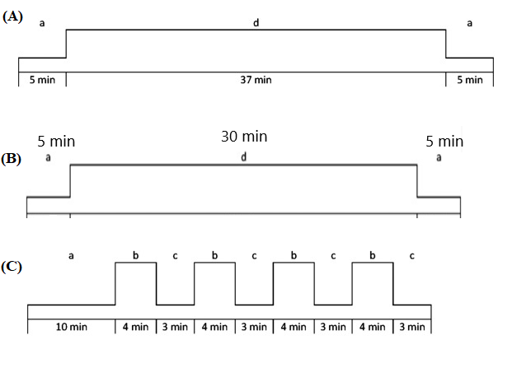
Fig. 1. Training protocol in this study. (A): moderate intensity aerobic exercise (MIT) protocol, (B): intense aerobic exercise (HIT) protocol, (C): intense intermittent aerobic exercise (HIIT) protocol.
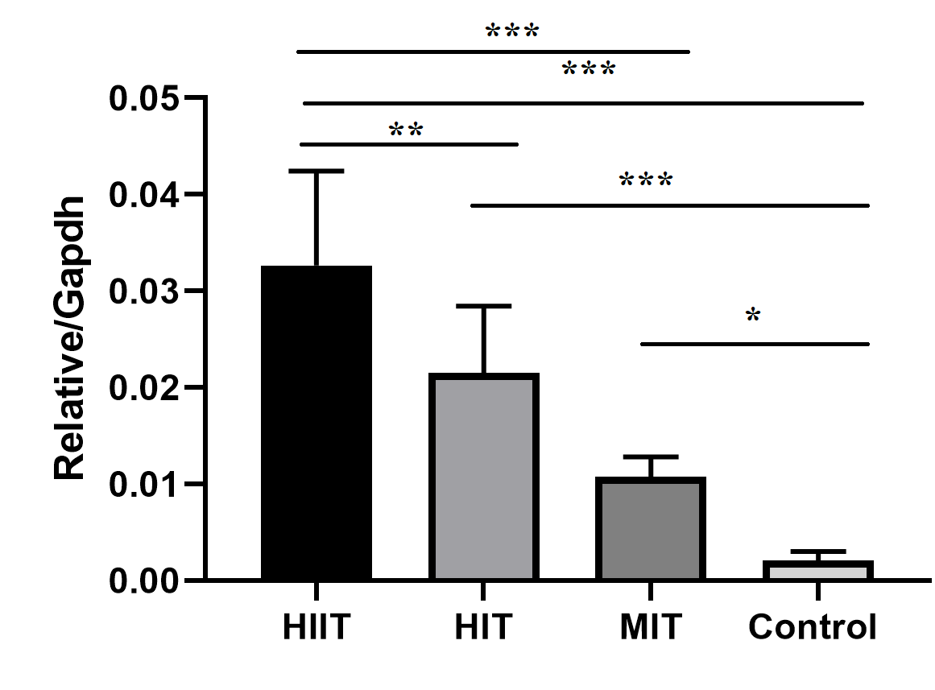
Fig. 2. Changes in JNK gene expression in the liver tissue of male Wistar rats in the study groups. *P < 0.05, **p<0.01 and ***P < 0.001. *The comparison was made between groups.
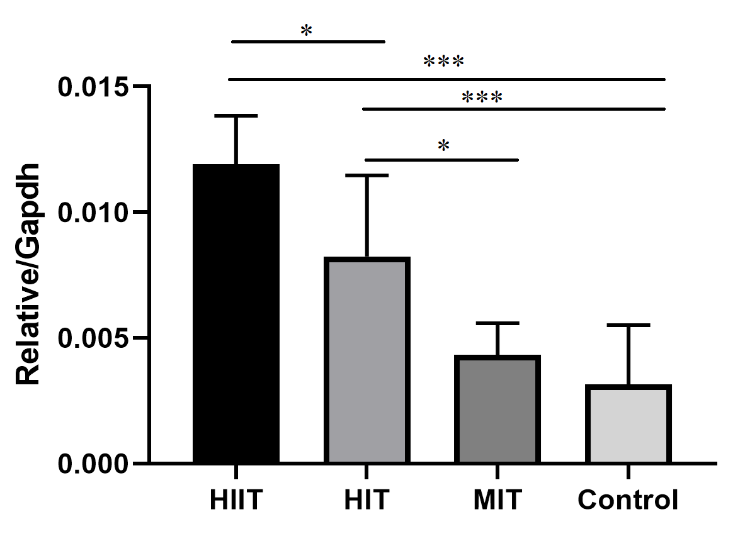
Fig. 3. Changes in ERK gene expression in the liver tissue of male Wistar rats in Study Groups. *P < 0.05, and ***P < 0.001. *The comparison was made between groups.

