Syringic acid attenuates sodium arsenite-induced nephrotoxicity in mice through oxidative stress, inflammation, and the NF-κB-p65 signaling pathway

Running title: Effect of syringic acid on reducing sodium arsenite nephrotoxicity.

Abstract
Background: Arsenic is widely found in the environment, and its toxicity is a significant public health issue worldwide. Syringic acid (SYRA) is a flavonoid compound with anti-inflammatory effects. Given that the effect of SYRA on sodium arsenite (As)-induced nephrotoxicity remains largely unknown, this study aimed to investigate the effect of SYRA on sodium arsenite-induced nephrotoxicity in mice by reducing oxidative stress, inflammation, and nuclear factor kappa B p-65 (NF-κB- p65) expression.
Methods: Thirty male mice were split into five groups of six, based on a power analysis. The groups were set up like this: control (3 ml/kg normal saline); SYRA (25 mg/kg, administered via gavage); As (3 mg/kg, administered via gavage); As + SYRA (10 mg/kg, administered via gavage) and As + SYRA (25 mg/kg, administered via gavage). As was administered daily via gavage for a total of 30 days. SYRA was then given by gavage for 7 days, from day 23 to day 30. On the 30th day, the mice were put under anesthesia, and samples of their heart blood and kidney tissue were taken to check biochemical markers, oxidative stress, inflammatory factors, and the expression of NF-κB-p65 protein.
Results: Giving SYRA lowered the levels of blood urea nitrogen, creatinine, and uric acid in the blood compared to the As group (P<0.001). In the SYRA group, levels of total thiol, catalase, superoxide dismutase, and glutathione peroxidase were higher compared to the As group (P<0.001). The SYRA group showed lower levels of thiobarbituric acid-reactive substances, nitric oxide, tumor necrosis factor alpha, and NF-κB-p65 protein expression compared to the As group (P<0.001). The histological results backed up these findings.
Conclusion: Giving SYRA might help reduce kidney damage caused by As in mice by lowering oxidative stress, inflammation, and the expression of NF-κB-p65 protein.
Keywords: Syringic acid, Sodium arsenite, Nephrotoxicity, Oxidative stress, inflammation.

Introduction
Arsenic is found all over the environment, and arsenic toxicity is a serious public health issue that affects people around the world. The World Health Organization says that over 200 million people across 35 countries are drinking water with high levels of arsenic (1). Arsenic is a poisonous metal that naturally shows up in both inorganic forms like arsenite and arsenate, and organic forms such as arsenobetin, arsenoculin, and arsenosugars. Arsenite is found in the +3-oxidation state, while arsenate exists in the +5-oxidation state (2). Arsenate in drinking water gets absorbed easily through the digestive system. This metabolism happens in the liver, where arsenate is turned into arsenite by purine nucleoside phosphorylase (PNP) and glutathione-s-transferase omega. Arsenite is far more toxic than arsenate and can harm the digestive system, sometimes causing death through shock (3). Arsenic can mess with how cells handle their redox reactions (4). Sodium arsenite (As) mainly causes oxidative stress by producing reactive oxygen species (ROS) and interacting with the sulfhydryl groups found in proteins and enzymes (5). Arsenic causes ROS production, which can throw off the redox balance in tissues. Arsenic can bind to sulfhydryl groups, which leads to a drop in the activity of several cellular enzymes. This is especially true for enzymes involved in managing fatty acid oxidation and glutathione production (6). Histopathological studies show that arsenic leads to damage in the tubules, including loss of the brush border, dilation of the tubules, and tissue death. It also causes nephritis with swollen mitochondria, which can eventually result in acute renal failure. Arsenic builds up in the kidney and harms the structure and function of the convoluted tubules nearby by raising oxidative stress (7). In China and Chile, people who have been drinking water with arsenic have reported cases of kidney cancer, nephritis, and nephrosis (8). Long-term exposure to arsenic can cause protein to appear in urine, harm kidney function, and raise the chances of developing chronic kidney disease (9). Polyphenols are one of the most common antioxidants we get from our diet. These compounds fall into four main groups: phenolic acids, flavonoids, lignins, and stilbenes. Syringic acid (SYRA) is a natural compound found in plants like olives, grapes, pomegranates, green tea, and mushrooms. It works by blocking the oxidation of low-density lipoprotein and helps get rid of free radicals, which in turn lowers the amount of malondialdehyde produced. SYRA has properties that help reduce oxidation, inflammation, and high lipid levels. SYRA has been found to protect Wistar rats from damage to their brain, heart, liver, and kidneys (10). There have been a number of reports showing that SYRA can help prevent cancer, diabetes, as well as inflammatory and infectious diseases (11). NF-κB is a transcription factor that plays a role in apoptosis, viral replication, tumorigenesis, inflammation, and several autoimmune diseases (12). The transcription factor NF-κB plays a key role in controlling different parts of both innate and adaptive immune functions and is an important player in inflammatory responses. NF-κB causes the production of several proinflammatory genes, including those that make cytokines and chemokines. NF-κB also plays a key role in controlling the survival, activation, and differentiation of innate immune cells and inflammatory T cells. Prabu et al. The study showed that As raises the level of the protein NF-κB in kidney tissue. Unlike silibinin, because of its antioxidant effects, it noticeably lowered arsenic toxicity and kept the kidney tissue's normal structure intact (14).
Since SYRA has shown antioxidant and anti-inflammatory effects in several studies, it looks like it could help lessen the oxidative stress and kidney inflammation caused by arsenic. Because no research has looked at whether SYRA can protect against arsenic-caused kidney damage, this study aimed to see if SYRA has a protective effect by checking its impact on oxidative stress, inflammation, and the NF-κB-p65 protein in the kidney.

Materials and Methods
Drugs and chemicals
Sodium arsenite (purity ≥ 90%, CAS: 7784-46-5) and synergic acid (purity ≥ 99%, CAS: 530-57-4) were acquired from Sigma-Aldrich, USA. Assay kits for blood urea nitrogen (BUN), creatinine (Cr), and uric acid (UA) were sourced from Pars Azmoon Company, Iran. Kits for measuring superoxide dismutase (SOD), catalase (CAT), glutathione peroxidase (GPx), and nitric oxide (NO) were obtained from ZellBio Company, Germany. The tumor necrosis factor-alpha (TNF-α) ELISA kit was procured from Karmania Pars Gene, Iran.
Animals and ethical statement
In this research, thirty male NMRI mice (aged 6–8 weeks, with an average weight of 25±2 g) were allocated into five groups, each consisting of 6 mice. The mice were maintained at a temperature of 23 ± 2 °C, with humidity levels ranging from 40% to 50%, and were exposed to a cycle of 12 hours of light followed by 12 hours of darkness. Additionally, they were given adequate food and water. All procedures involving animals were performed in compliance with the ethical guidelines established by Ahvaz Jundishapur University of Medical Sciences (ethics number: IR.AJUMS.AEC.1403.021).
Experimental design
A total of thirty male mice were divided into five groups of six based on a power analysis. Following this, randomization was performed using computer-generated sequences along with assignment concealment. We preregistered our analyses with the Open Science Framework, which advocates for reproducibility and collaborative efforts in scientific research. The purpose of the preregistration was to limit the number of analyses conducted and to demonstrate our commitment to evaluating a specific set of a priori hypotheses. Our methodologies are consistent with this preregistration. This study received funding from the Toxicology Research Center, Medical Basic Sciences Research Institute of the AJUMS Foundation in Iran (03s54). The classification of the groups was as follows: control (3 ml/kg normal saline), SYRA (25 mg/kg, gavage), As (3 mg/kg, gavage), As + SYRA (10 mg/kg, gavage), and As + SYRA (25 mg/kg, gavage). The dosages of As and SYRA were determined based on prior research (15-17). As was administered via gavage daily for a total of 30 days. Following this, SYRA was given through gavage for 7 days (23-30). On the 30th day, the mice were anesthetized using ketamine (80 mg/kg) and xylazine (8 mg/kg), and samples of heart blood and kidney tissue were collected to assess biochemical markers, oxidative stress, inflammatory factors, and NF-κB-p65 protein expression.
Sample preparation and protein content assay
To achieve this, kidney tissue was homogenized in phosphate buffer and subsequently centrifuged. The supernatant was then collected and preserved at −70 °C for the assessment of tissue factors, which include total thiol, TBARS, CAT, SOD, GPx, NO, TNF-α, and NF-κB-p65 protein expression. The concentration of protein in the supernatants was measured using the Bradford method. Absorbance readings were recorded at 595 nm (18).
Measurement of serum and tissue factors
The serum levels of BUN, Cr, and U.A were quantified utilizing commercial detection kits from Pars Azmoon Company and the Hitachi 912 auto-analyzer from Japan, with results reported in mg/dl.
The total thiol concentration was determined using Ellman’s reagent (19), which generates yellow TNB. The absorbance was measured at 412 nm and expressed as nmol/mg of protein.
The TBARS concentration was assessed using the Kei method (20). The absorbance of the resulting pink color was measured at 532 nm and reported as nmol/mg protein.
The activities of the antioxidant enzymes SOD, CAT, and GPx were evaluated using ZellBio assay kits from Germany, with results documented as U/mg protein.
The evaluation of TNF-α level was performed using a commercial kit, with absorbance readings taken at 450 nm and recorded as pg/mg protein.
The measurement of NO level was conducted using ZellBio assay kits from Germany, with results expressed as nmol/mg protein.
Western blotting
A total of 20 µg of protein from each group underwent electrophoresis utilizing sodium dodecyl sulfate polyacrylamide gel electrophoresis, followed by a transfer to a polyvinylidene difluoride membrane. The membranes were treated with primary antibodies, using anti-NF-κB p65 at a 1:500 dilution (Cat No: 3034, Cell Signaling Technology, USA) and anti-GAPDH at the same 1:500 dilution (Cat No: 5174, Cell Signaling Technology, USA). Subsequently, the membranes were treated with mouse anti-rabbit IgG-HRP at a 1:1000 dilution (Cat No: sc-2357, Santa Cruz Biotechnology, Inc.). To visualize the protein bands, an electrochemiluminescence kit (Abcam, 133408, USA) was used, and Image Lab™ Touch software (Bio-Rad, USA) was employed for band quantification. GAPDH was used as the loading control in the Western blotting.
Histopathological analysis
After the blood was collected, the kidneys were quickly taken out and placed in a 10% formalin solution for preservation. After that, they were dried out with increasing amounts of alcohol and then set in paraffin. Sections that were 4-6 µm thick were cut and stained using hematoxylin and eosin (H&E).For each animal, we looked at three microscopy slides to check for changes like glomerulus atrophy and damage, breakdown of the epithelial lining, signs of inflammation, and congestion. Tissue damage and changes were sorted into four groups: normal (0), weak (1), moderate (2), or intense (3), and then the averages were calculated. Histopathological evaluations were done by mixing up the order of the slides and having a pathologist look at them.
Statistical analysis

Statistical analysis was conducted using GraphPad Prism version 9, and the normality of the data was assessed through the Kolmogorov-Smirnov test. The Mean ± standard deviation for each group was determined, and the results were evaluated using one-way ANOVA, followed by Tukey's post hoc test for multiple comparisons. A significance level of P<0.05 was established.

Results
Impact of SYRA on the serum biochemical factors
The influence of SYRA on serum biochemical factors is depicted in Fig.1. Accordingly, the serum levels of BUN, Cr, and U.A were significantly increased in the As group compared to the control group (P<0.001). The administration of SYRA 10 and 25 mg/kg resulted in a decrease in BUN, Cr, and U.A when compared to the As group. The impact of SYRA 25 mg/kg on the biochemical factors was more pronounced than that of SYRA 10 mg/kg (P<0.001).
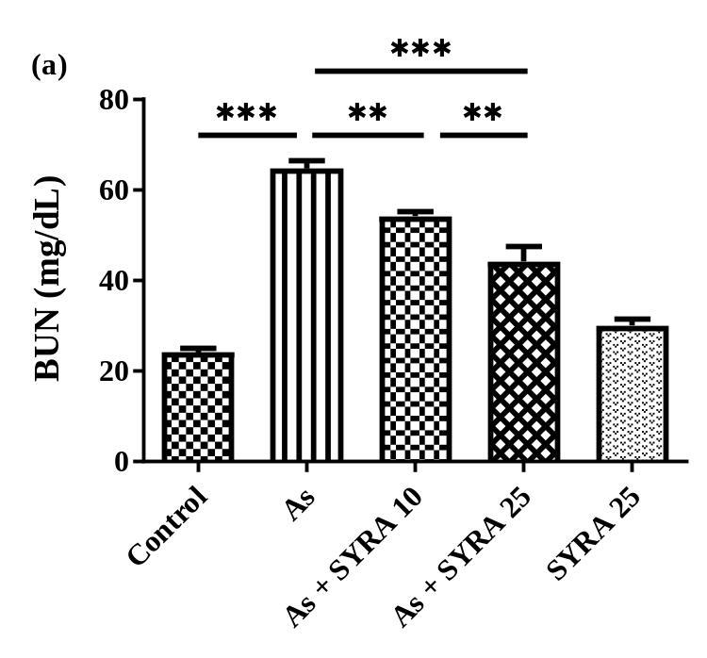
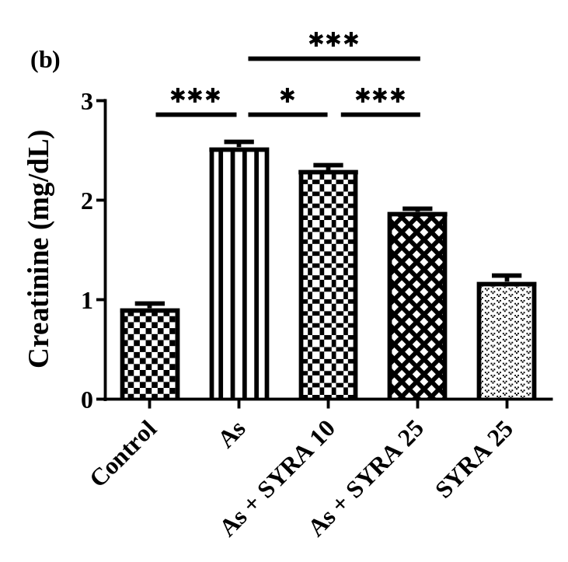
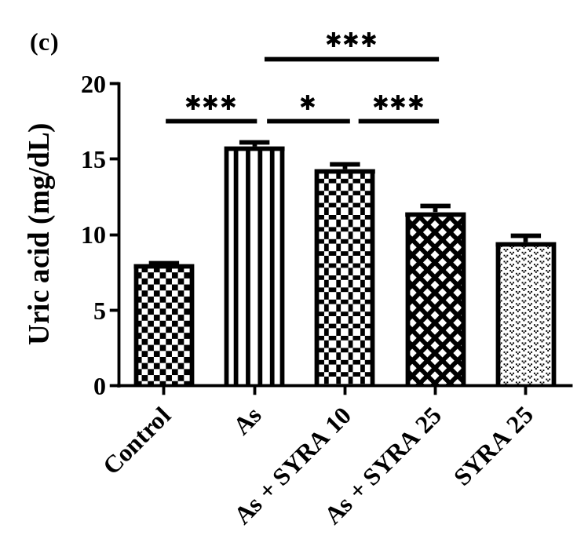
Fig. 1. Impact of syringic acid (SYRA) on the levels of (a) blood urea nitrogen (BUN), (b) creatinine, and (c) uric acid in sodium arsenite (As)-induced nephrotoxicity in mice. Data are presented as mean ± standard deviation (n=6) and confidence intervals 95%. (*P<0.05, **P<0.01, and ***P<0.001).

Impact of SYRA on the oxidative stress markers
The impact of SYRA on oxidative stress markers is illustrated in Fig. 2. Accordingly, the levels of total thiol, CAT, SOD, and GPx in the As group were significantly lower than those observed in the control group (P<0.001). The As group treated with SYRA 10 and 25 mg/kg demonstrated significantly elevated levels of total thiol, SOD, CAT, and GPx when compared to the As group (P<0.001). An increase in TBARS level was observed in the As group relative to the control group (P<0.001). In contrast, the As groups that received treatment with SYRA 10 and 25 mg/kg exhibited a significant reduction in TBARS level (P<0.001). The effect of SYRA 25 mg/kg was more pronounced than that of SYRA 10 mg/kg (P<0.001).
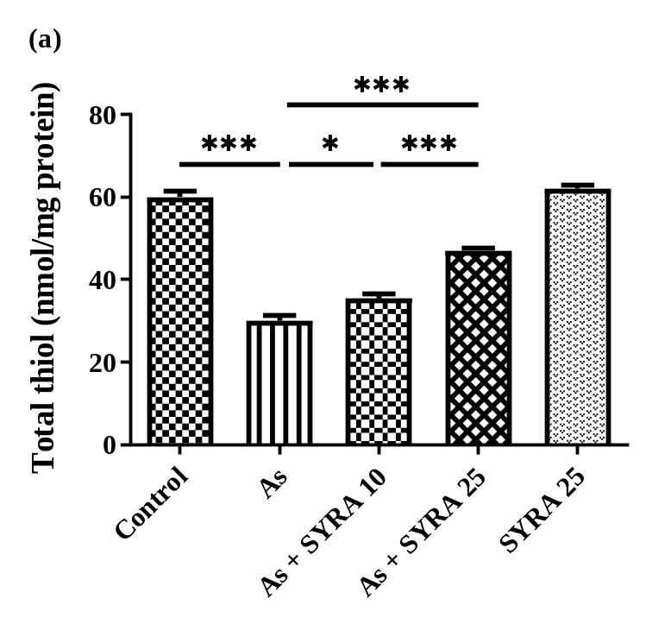
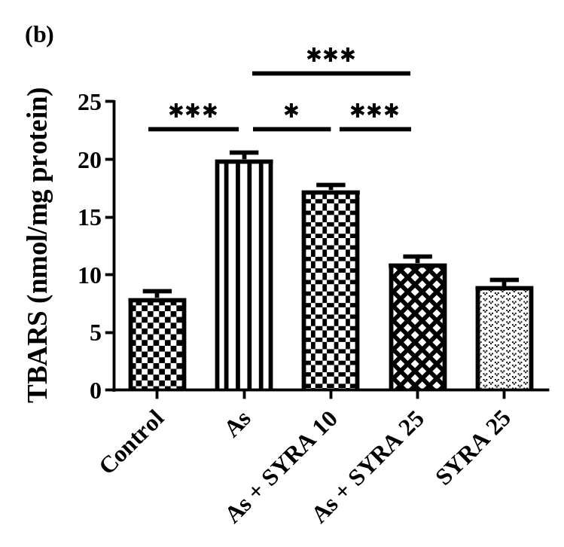
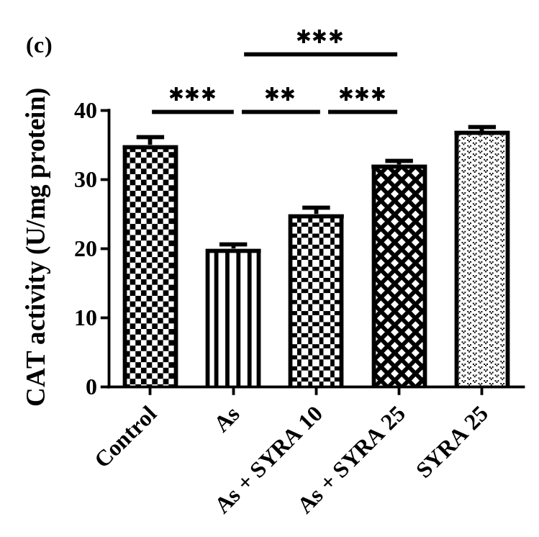
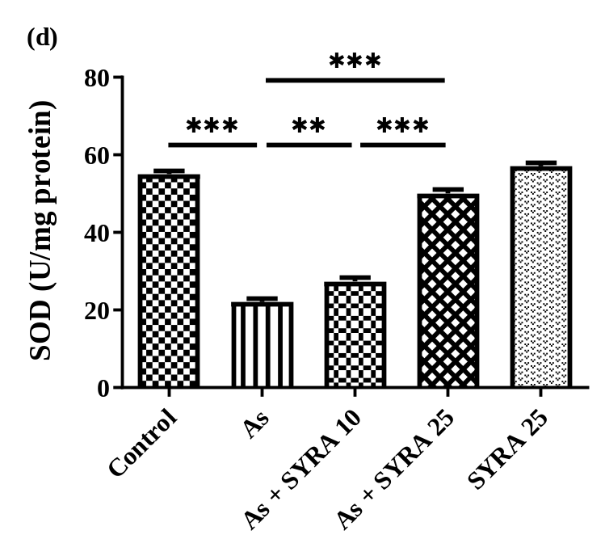
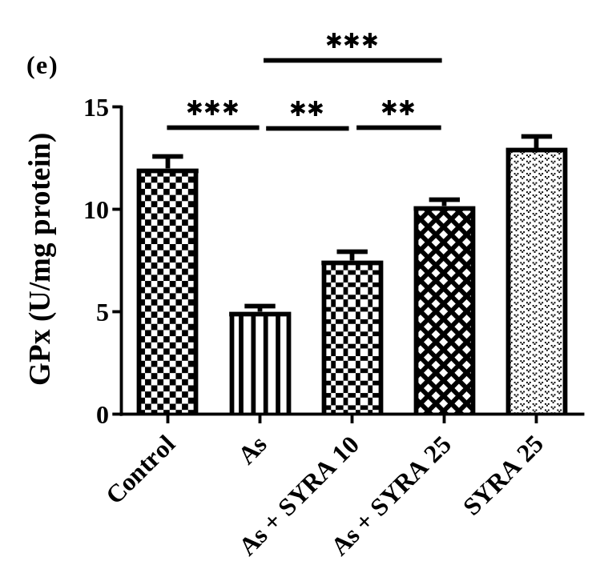
Fig. 2. Impact of syringic acid (SYRA) on the levels of (a) total thiol, (b) thiobarbituric acid reactive substances (TBARS), (c) catalase (CAT) activity, (d) superoxide dismutase (SOD) activity, and (e) glutathione peroxidase (GPx) in sodium arsenite (As)-induced nephrotoxicity in mice. Data are presented as mean ± standard deviation (n=6) and confidence intervals 95%. (*P<0.05, **P<0.01, and ***P<0.001).

Impact of SYRA on the inflammatory markers
The impact of SYRA on the inflammatory markers TNF-α and NO is illustrated in Fig. 3. The results demonstrated a significant increase in the levels of TNF-α and NO following As administration when compared to the control group (P<0.001). Both SYRA 10 mg/kg and SYRA 25 mg/kg showed an enhancement in these markers, resulting in a substantial decrease in TNF-α and NO levels in the treated groups relative to the As group. The effect of SYRA 25 mg/kg was markedly more pronounced than that of SYRA 10 mg/kg (P<0.001).
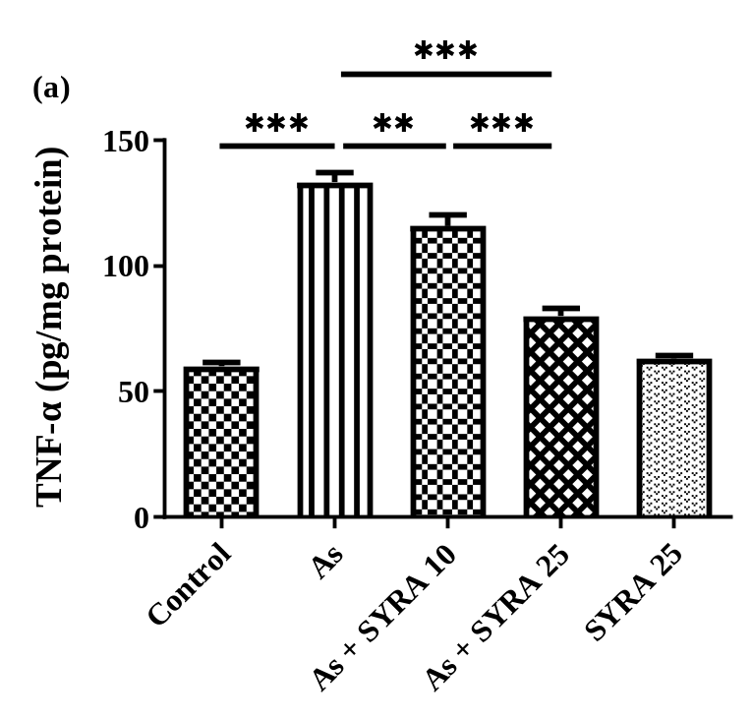
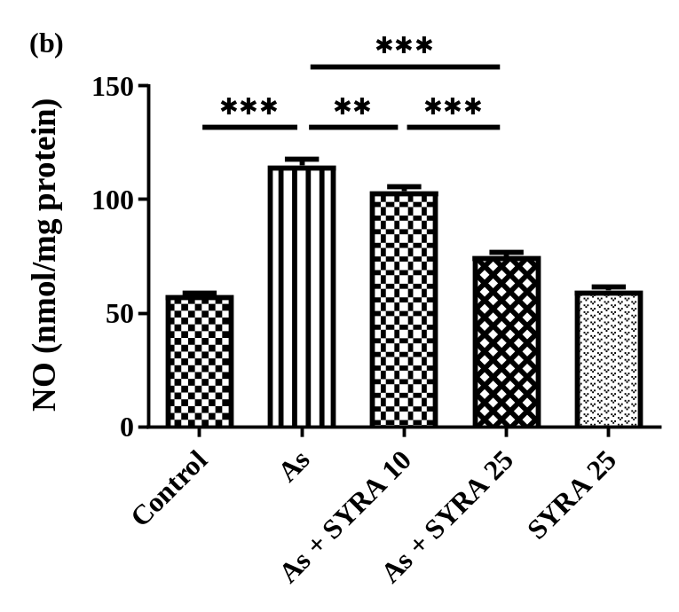
Fig. 3. Impact of syringic acid (SYRA) on the inflammatory markers of (a) tumor necrosis factor-alpha (TNF-α) and (b) nitric oxide (NO) in sodium arsenite (As)-induced nephrotoxicity in mice. Data are presented as mean ± standard deviation (n=6) and confidence intervals 95 %.(**P<0.01 and ***P<0.001).

Impact of SYRA on the NF-κB-p65 protein expression
The impact of SYRA on the expression of the NF-κB-p65 protein is illustrated in Fig. 4. The NF-κB-p65 protein expression level in the As group showed a notable increase in comparison to the control group (P<0.001). In the treatment groups administered either SYRA 10 mg/kg or SYRA 25 mg/kg, the expression of this protein was significantly reduced relative to that observed in the As group (all P<0.001). Moreover, the effect of SYRA 25 mg/kg was determined to be significantly more potent than that of SYRA 10 mg/kg (P<0.001).
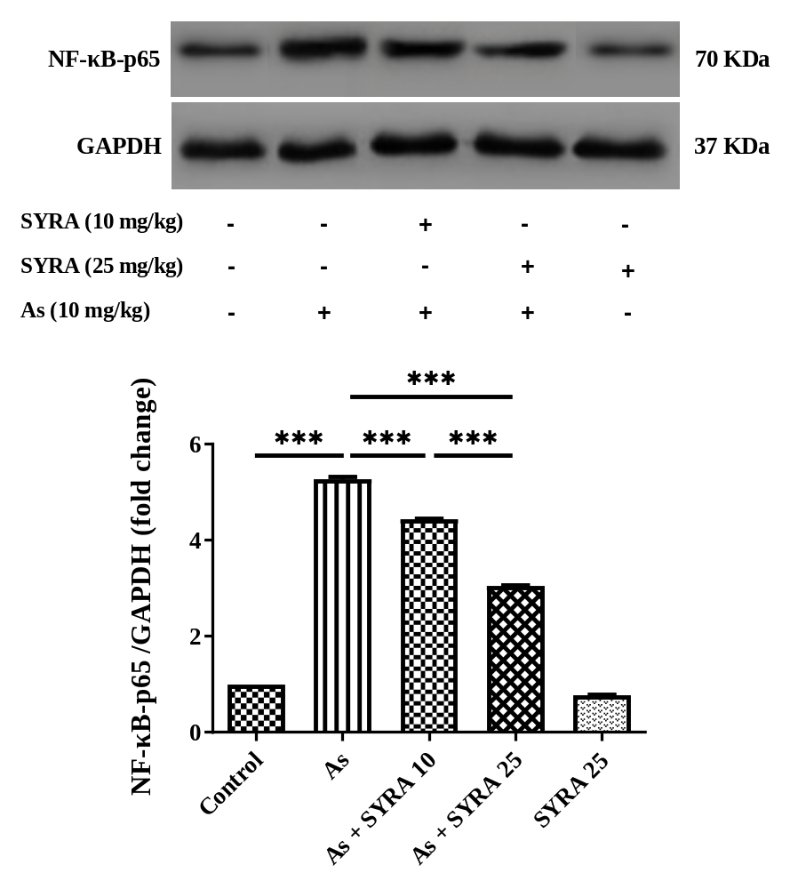
Fig. 4. Impact of syringic acid (SYRA) on the nuclear factor kappa B p-65 (NF-κB-p65) protein expression in sodium arsenite (As)-induced nephrotoxicity in mice. Data are presented as mean ± standard deviation (n=3) and confidence intervals 95%. (***P<0.001).

Impact of SYRA on the histopathological factors
The findings of this research indicated that the kidney tissue in the control group exhibited a normal structural composition. The glomeruli and tubular tissue appeared normal. Notable signs of kidney tissue damage, such as glomerular injury, vacuolar degeneration, destruction of the tubular epithelium, and enlargement of the tubular lumen, were identified in the As-treated group (Fig. 5). Administration of SYRA at doses of 10 mg/kg or 25 mg/kg significantly ameliorated the previously mentioned renal degenerative alterations. The extent of these damages and tissue modifications was more pronounced in the cohort of patients treated with SYRA 25 mg/kg compared to those receiving SYRA 10 mg/kg. The quantitative assessment illustrating the average areas of damaged tissue for each group is presented in Fig. 6. As a result, the As group demonstrated the highest percentage of tissue damage (P<0.001). In contrast, the treatment groups that received SYRA 10 mg/kg or SYRA 25 mg/kg exhibited a decrease in tissue damage (P<0.001).
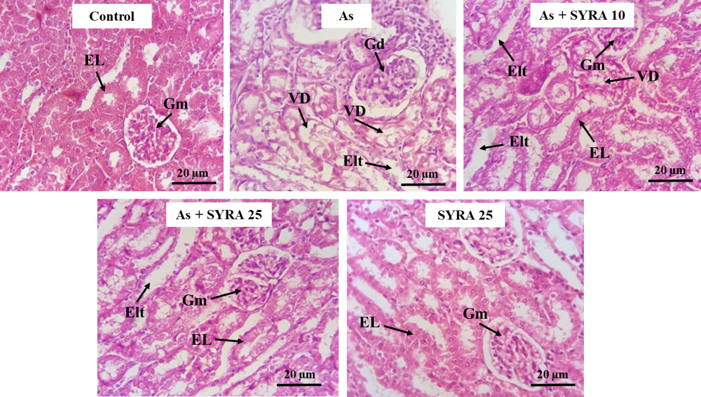

Fig. 5. Light microscopy examination of kidney tissue sections that stained by H&E in different groups. Groups consist of control, sodium arsenite (As), As + syringic acid 10 mg/kg (As + SYRA 10), As+ syringic acid 25 mg/kg (As + SYRA 25), SYRA 25 mg/kg. Glomerulus (Gm), Glomerular disorganization (Gd), Epithelial lining (EL) and Vacuolar degeneration (VD), and Enlargement of tubular lumen (Elt). Magnification: ×400.
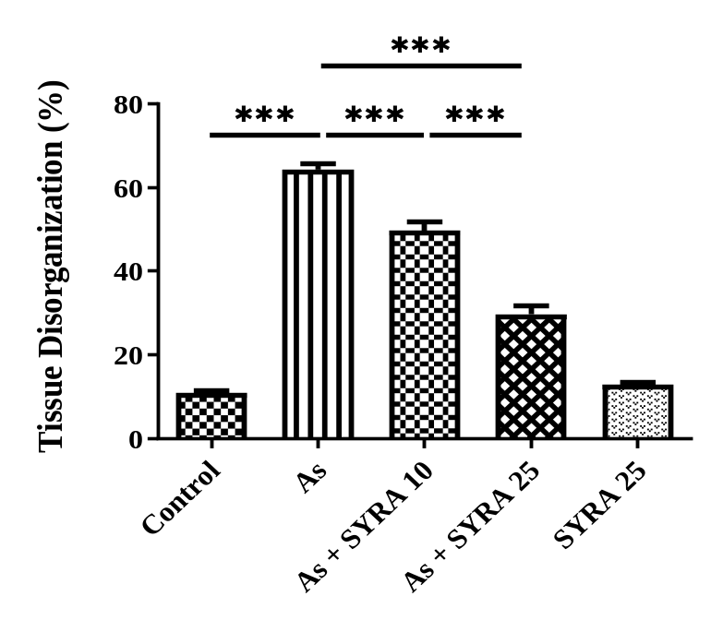
Fig. 6. Impact of syringic acid (SYRA) on the tissue destruction in the sodium arsenite (As)-induced nephrotoxicity in mice. Data are presented as mean ± standard deviation (n=6) and confidence intervals 95%. (***P<0.001).

Discussion
This study shows that SYRA treatment helps reduce kidney damage caused by As in mice by bringing back normal kidney function and structure. In this study, SYRA helped protect the kidney's glomerular and tubular parts in a way that depended on the dose, lowering the levels of blood markers for kidney damage like BUN, Cr, and U.A).The improvement showed up best at a dose of 25 mg/kg SYRA. Recent studies show that phenolic acids can help reduce organ damage caused by drugs by working through antioxidant pathways (21-23). Our findings on the nephroprotective capacity of SYRA match what earlier studies found about its ability to protect against oxidative damage (24). SYRA’s ability to protect the kidneys probably comes from its 4-hydroxy-3, 5-dimethoxybenzoic acid structure. Having methoxy groups at positions 3 and 5 adds more electron density, which helps stabilize the phenoxy radical that comes from the hydroxyl group at position 4. This particular chemical setup boosts its ability to donate hydrogen atoms and neutralize ROS more than regular benzoic acid derivatives (25, 26). The main reason for As-induced kidney damage is that it messes up the balance of cellular redox, causing the body's natural antioxidants to run low and ROS to build up (27). It has a strong attraction to sulfhydryl groups in proteins, which stops important antioxidant enzymes from working and damages the mitochondria (28). In this study, As caused a noticeable drop in total thiol levels and lowered the activity of the antioxidant enzymes SOD, CAT, and GPx, which is in accordance with the results of the study Alvandi et al. (29). On the other hand, SYRA boosted the total thiol level and the activity of antioxidant enzymes while lowering the lipid peroxidation marker TBARS. SYRA keeps the mitochondria and structure of kidney tubular cells intact by stopping arsenic from messing with the sulfhydryl groups of antioxidant enzymes and by directly cleaning up ROS. Higher activity of SOD, CAT, and GPx shows that the nuclear factor erythroid 2-related factor 2 (Nrf-2) pathway is active. Nrf-2 acts as a transcriptional regulator that controls the expression of antioxidant enzymes by targeting antioxidant response elements (30). Activating Nrf-2 is likely a key way that a phenolic compound like SYRA can fight against the loss of natural antioxidant enzymes caused by As, by boosting specific gene transcription and bringing redox balance back to normal (31). Nrf-2 and NF-κB tend to work in opposite ways, so when the Nrf-2 pathway is more active, it probably helps reduce inflammation by suppressing NF-κB, which is what we saw in this study (32,33). Restoring the antioxidant defense system stops the early stage of cell damage that usually leads to cell death and tissue necrosis (34, 35). Besides causing direct oxidative damage, As toxicity also triggers the NF-κB signaling pathway, which plays a key role in the inflammatory response and connects oxidative stress to tissue damage. When ROS level go up, it causes NF-κB-p65 to move into the nucleus, which then ramps up the production of proinflammatory cytokines (36). In this study, SYRA treatment clearly lowered the levels of NF-κB-p65 protein, which was linked to a noticeable drop in inflammatory molecules like TNF-α and NO. It is important to point out the suppression of NO because when there is too much NO along with superoxide anions, they can create peroxynitrite, which is harmful to the renal tubules (37). These data suggest that SYRA works in two ways: it scavenges the free radicals that start the signaling and it changes the signaling inside cells, which stops the progression of renal nephritis. SYRA stops the NF-κB pathway, which helps end the cycle of oxidative stress and inflammation, and it keeps harmful inflammatory cells from gathering in the tissue. We know the NF-κB pathway is a target, but we have not figured out which specific upstream kinases are involved in controlling this signaling yet. The molecular mechanisms found, especially the way SYRA affects both the NF-κB pathway and oxidative stress markers at the same time, offer a solid pharmacological explanation for its protective effects, no matter how long the exposure lasts. The kidney is a main organ where As builds up and causes harm because it filters and helps get rid of toxins (38). In this study, giving As led to tubular necrosis, vacuolar degeneration, problems with glomerular function, and eventually serious kidney damage, which matches what earlier research found (39, 40). These findings look hopeful, but because the study only used a 30-day mice model, we cannot be sure the results apply to people who have been exposed to low levels of arsenic in drinking water over a long time. Another limitation of this study is that mice metabolize and clear substances differently than humans do. In addition, the exact amount of arsenic that built up in kidney tissue after treatment was not measured, so it is unclear whether SYRA helps get rid of arsenic by binding to it or just lessens its harmful effects in the cells (41, 42). Because SYRA has nearby carboxyl and hydroxyl groups, it is reasonable to think it might work as a chelating agent, binding with arsenic to help the body get rid of it through urine. This idea is something future pharmacokinetic studies might explore (43). Therefore, taking these results and applying them to humans, the effective dose in mice at 25 mg/kg translates to about 2 mg/kg for humans. This dose is comfortably within the range people might get from their diet or supplements, showing that SYRA could be a good option to help people who are exposed to environmental arsenic. All these findings together support the idea that SYRA’s treatment benefits come from stopping the harmful chain reaction of oxidative stress and inflammation caused by arsenic exposure, and from preventing kidney damage from getting worse and turning into acute failure.

Conclusion
Our research showed that SYRA could reduce As-induced nephrotoxicity in mice by reducing oxidative stress, inflammation, and NF-κB-p65 protein expression. Notably, the impact of SYRA 25 mg/kg was significantly greater than that of SYRA 10 mg/kg.

Acknowledgements
The authors would like to express their heartfelt gratitude and appreciation to the Toxicology Research Center, Department of Toxicology, Faculty of Pharmacy, Ahvaz Jundishapur University of Medical Sciences (AJUMS) in Ahvaz for their partnership in carrying out this study (ethics number: IR.AJUMS.AEC.1403.021).

Funding
The Toxicology Research Center, Medical Basic Sciences Research Institute of the AJUMS Foundation in Iran (03s54) supported the current research.

Conflicts of interest
The authors affirm that they possess no recognized competing financial interests or personal connections that might have seemed to affect the work presented in this manuscript. This research did not obtain any particular grant from funding organizations in the public, commercial, or non-profit sectors.

References
1. Kumar M, Thakur R. Syzygium cumini seed extract ameliorates arsenic-induced blood cell genotoxicity and hepatotoxicity in Wistar albino rats. Rep Biochem Mol Biol. 2018; 7(1):110.
2. Ganie SY, Javaid D, Hajam YA, Reshi MS. Arsenic toxicity: sources, pathophysiology and mechanism. Toxicol Res (Camb).2024; 13(1): tfad111. Epub 20231208.
3. Sepahvand A, Farhadi M, Mohammadi MJ, Bayat M, Falahi B, Ghanizadeh F, et al. A Review of the Effect of Drinking Water Contaminated with Arsenic on Liver Cancer. Avicenna J Environ Health Eng. 2024; 11(1):47-54.
4. Delaney P, Ramdas Nair A, Palmer C, Khan N, Sadler KC. Arsenic induced redox imbalance triggers the unfolded protein response in the liver of zebrafish. Toxicol Appl Pharmacol. 2020; 409:115307.
5. El-Demerdash FM, Yousef MI, Radwan FME. Ameliorating effect of curcumin on sodium arsenite-induced oxidative damage and lipid peroxidation in different rat organs. Food and Chemical Toxicology.2009; 47(1):249-54.
6. Nahar K, Rhaman MS, Parvin K, Bardhan K, Marques DN, García-Caparrós P, et al. Arsenic-Induced Oxidative Stress and Antioxidant Defense in Plants. Stresses.2022; 2(2):179-209.
7. Ranasinghe R, Mathai M, Zulli A. Cytoprotective remedies for ameliorating nephrotoxicity induced by renal oxidative stress. Life Sciences. 2023; 318:121466.
8. Ferreccio C, Smith AH, Durán V, Barlaro T, Benítez H, Valdés R, et al. Case-control study of arsenic in drinking water and kidney cancer in uniquely exposed Northern Chile. Am J Epidemiol.2013; 178(5):813-8.
9. Zheng L, Kuo CC, Fadrowski J, Agnew J, Weaver VM, Navas-Acien A. Arsenic and Chronic Kidney Disease: A Systematic Review. Curr Environ Health Rep. 2014; 1(3):192-207.
10. Ciupei D, Colişar A, Leopold L, Stănilă A, Diaconeasa ZM. Polyphenols: From Classification to Therapeutic Potential and Bioavailability. Foods. 2024; 13(24).
11. Alhalabi M, Alshiekh HA, Alsaiad S, Zarzar M. Prevalence of opportunistic infections in Syrian inflammatory bowel disease patients on biologic therapy: a multi-center retrospective cross-sectional study. BMC Infect Dis. 2025; 25(1):652.
12. Barnabei L, Laplantine E, Mbongo W, Rieux-Laucat F, Weil R. NF-κB: At the Borders of Autoimmunity and Inflammation. Front Immunol. 2021; 12:716469. Epub 20210809.
13. Liu T, Zhang L, Joo D, Sun SC. NF-κB signaling in inflammation. Signal Transduct Target Ther.2017; 2:17023.
14. Prabu SM, Muthumani M. Silibinin ameliorates arsenic induced nephrotoxicity by abrogation of oxidative stress, inflammation and apoptosis in rats. Mol Biol Rep. 2012; 39(12):11201-16.
15. Fang W, Zhu S, Niu Z, Yin Y. The protective effect of syringic acid on dextran sulfate sodium-induced experimental colitis in BALB/c mice. Drug Dev Res. 2019; 80(6):731-40.
16. Itoh A, Isoda K, Kondoh M, Kawase M, Watari A, Kobayashi M, et al. Hepatoprotective effect of syringic acid and vanillic acid on CCl4-induced liver injury. Biol Pharm Bull.2010; 33(6):983-7.
17. Singh MK, Dwivedi S, Yadav SS, Yadav RS, Khattri S. Anti-diabetic Effect of Emblica-officinalis (Amla) Against Arsenic Induced Metabolic Disorder in Mice. Indian J Clin Biochem.2020; 35(2):179-87.
18. He F. Bradford Protein Assay. BIO-PROTOCOL. 2011;1.
19. Winther JR, Thorpe C. Quantification of thiols and disulfides. Biochim Biophys Acta.2014; 1840(2):838-46.
20. Satoh K. Serum lipid peroxide in cerebrovascular disorders determined by a new colorimetric method. Clin Chim Acta.1978; 90(1):37-43.
21. Alwaili MA, Eid TM, Abu-Almakarem AS, Alsirhani AM, Al-Sowayan NS, Aljarari RM, et al. Syringic Acid Alleviates Doxorubicin-Induced Hepatotoxicity Through PI3K/Akt-Mediated Nrf-2/HO-1 Signaling Pathways in Male Rats. International Journal of Molecular Sciences. 2025; 26(16):7779.
22. Shahzad S, Mateen S, Naeem SS, Akhtar K, Rizvi W, Moin S. Syringic acid protects from isoproterenol induced cardiotoxicity in rats. Eur J Pharmacol. 2019; 849:135-45.
23. Chen Y, Mei YQ, Hou L, Li KJ. Therapeutic potential of plant-derived natural products against drug-induced liver injury. Front Pharmacol.2025; 16:1652860.
24. Adeyi OE, Somade OT, Ajayi BO, James AS, Adeyi AO, Olayemi ZM, et al. Syringic acid demonstrates better anti-apoptotic, anti-inflammatory and antioxidative effects than ascorbic acid via maintenance of the endogenous antioxidants and downregulation of pro-inflammatory and apoptotic markers in DMN-induced hepatotoxicity in rats. Biochem Biophys Rep. 2023; 33:101428.
25. Vo QV, Bay MV, Nam PC, Quang DT, Flavel M, Hoa NT, et al. Theoretical and Experimental Studies of the Antioxidant and Antinitrosant Activity of Syringic Acid. J Org Chem. 2020; 85(23):15514-20.
26. Chen Y, Xiao H, Zheng J, Liang G. Structure-thermodynamics-antioxidant activity relationships of selected natural phenolic acids and derivatives: an experimental and theoretical evaluation. PLoS One. 2015; 10(3):e0121276.
27. Jomova K, Jenisova Z, Feszterova M, Baros S, Liska J, Hudecova D, et al. Arsenic: toxicity, oxidative stress and human disease. J Appl Toxicol.2011; 31(2):95-107.
28. Delaney P, Ramdas Nair A, Palmer C, Khan N, Sadler KC. Arsenic induced redox imbalance triggers the unfolded protein response in the liver of zebrafish. Toxicol Appl Pharmacol.2020; n409:115307.
29. Alvandi F, Matin M, Salehcheh M, Khorsandi L, Moosavi M. Herniarin Alleviates Sodium Arsenite-Induced Liver Toxicity in Mice by Attenuation of Oxidative Stress and Inflammation. Rep Biochem Mol Biol.2025; 14(2).
30. Zgorzynska E, Dziedzic B, Walczewska A. An Overview of the Nrf2/ARE Pathway and Its Role in Neurodegenerative Diseases. Int J Mol Sci. 2021; 22(17).
31. Tebay LE, Robertson H, Durant ST, Vitale SR, Penning TM, Dinkova-Kostova AT, et al. Mechanisms of activation of the transcription factor Nrf2 by redox stressors, nutrient cues, and energy status and the pathways through which it attenuates degenerative disease. Free Radic Biol Med. 2015; 88(Pt B):108-46.
32. Sivandzade F, Prasad S, Bhalerao A, Cucullo L. NRF2 and NF-қB interplay in cerebrovascular and neurodegenerative disorders: Molecular mechanisms and possible therapeutic approaches. Redox Biol. 2019; 21:101059.
33. Li W, Khor TO, Xu C, Shen G, Jeong WS, Yu S, et al. Activation of Nrf2-antioxidant signaling attenuates NFkappaB-inflammatory response and elicits apoptosis. Biochem Pharmacol. 2008; 76(11):1485-9.
34. Piko N, Bevc S, Hojs R, Ekart R. The Role of Oxidative Stress in Kidney Injury. Antioxidants (Basel).2023; 12(9).
35. Dragoș D, Enache, II, Manea MM. Oxidative Stress and Nutritional Antioxidants in Renal Diseases: A Narrative Review. Antioxidants (Basel).2025; 14(7).
36. Ren N, Wang WF, Zou L, Zhao YL, Miao H, Zhao YY. The nuclear factor kappa B signaling pathway is a master regulator of renal fibrosis. Front Pharmacol.2023; 14:1335094.
37. Pacher P, Beckman JS, Liaudet L. Nitric oxide and peroxynitrite in health and disease. Physiol Rev. 2007; 87(1):315-424.
38. Singh RD, Tiwari R, Sharma V, Khan H, Gangopadhyay S, Singh S, et al. Prenatal arsenic exposure induces immunometabolic alteration and renal injury in rats. Front Med (Lausanne).2022; 9:1045692.
39. Zargari M, Mohammadian M, Malekshah AK, Mianabadi M, Mogaddam AE, Amiri FT. Tyrosol and Olive Oil Ameliorate Sodium Arsenate-Induced Nephrotoxicity by Modulating of Oxidative Stress and Histological Changes in Mice. Int J Prev Med. 2023; 14:47.
40. Concessao PL, Prakash J. Arsenic-induced nephrotoxicity: Mechanisms, biomarkers, and preventive strategies for global health. Vet World.2025; 18(7):2136-57.
41. Vahter M. Methylation of inorganic arsenic in different mammalian species and population groups. Sci Prog. 1999; 82 (Pt 1) (1):69-88.
42. States JC, Barchowsky A. Invited Perspective: Humanized Mice for Arsenic Metabolism-A Better Model for Investigating Arsenic-Induced Diseases? Environ Health Perspect. 2023; 131(12):121308.
43. Gulcin İ, Alwasel SH. Metal Ions, Metal Chelators and Metal Chelating Assay as Antioxidant Method. Processes.2022; 10(1):132.

