Fig. 1

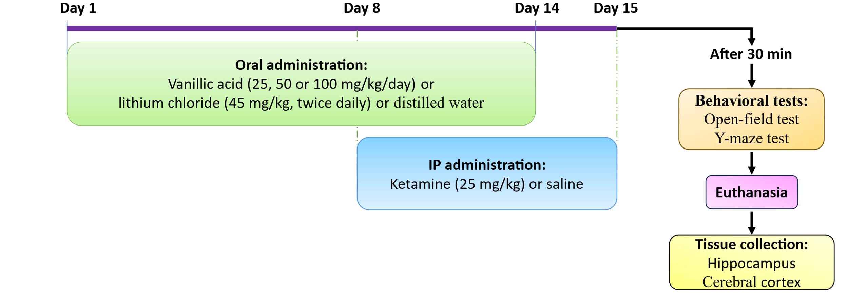
Figure 1. Schematic illustration of the experimental timeline in the study.

Fig. 2

Figure 2. Effects of vanillic acid (VA) (25, 50, and 100 mg/kg) and lithium on behavioral parameters in the ketamine-induced mania in rats. (A) Total crossings, (B) central crossings and (C) number of rearings. Data are expressed as mean ± SD (n = 6 per group). #P < 0.05, ##P < 0.01, ###P < 0.001 versus the vehicle/saline group. *P < 0.05, **P < 0.01, ***P < 0.001 versus the vehicle/ketamine group.

Fig. 3

Figure 3. Effects of VA (25, 50, and 100 mg/kg) and lithium on the percentage of spontaneous alternations in the Y-maze test in the ketamine-induced mania in rats. Data are expressed as mean ± SD (n = 6 per group). ###P < 0.001 versus the vehicle/saline group. *P < 0.05, **P < 0.01, ***P < 0.001 versus the vehicle/ketamine group.

Fig. 4.

Figure 4. Effects of VA (25, 50, and 100 mg/kg) and lithium on oxidative stress and antioxidant parameters in the ketamine-induced mania in cerebral cortex of rats. (A) MDA levels, (B) glutathione (GSH) levels, (C) catalase (CAT) activity and (D) superoxide dismutase (SOD) activity. Data are expressed as mean ± SD (n = 4-6 per group). #P < 0.05 and ##P < 0.01 versus the vehicle/saline group. *P < 0.05, **P < 0.01, ***P < 0.001 versus the vehicle/ketamine group.

Fig. 5.

Figure 5. Effects of VA (25, 50, and 100 mg/kg) and lithium on antioxidant markers in the hippocampus of rats in the ketamine-induced mania model. (A) GSH levels, (B) CAT activity, and (C) SOD activity. Data are expressed as mean ± SD (n = 4–6 per group). #P < 0.05, ###P < 0.001 versus the vehicle/saline group. *P < 0.05, **P < 0.01, ***P < 0.001 versus the vehicle/ketamine group.

Fig. 6.

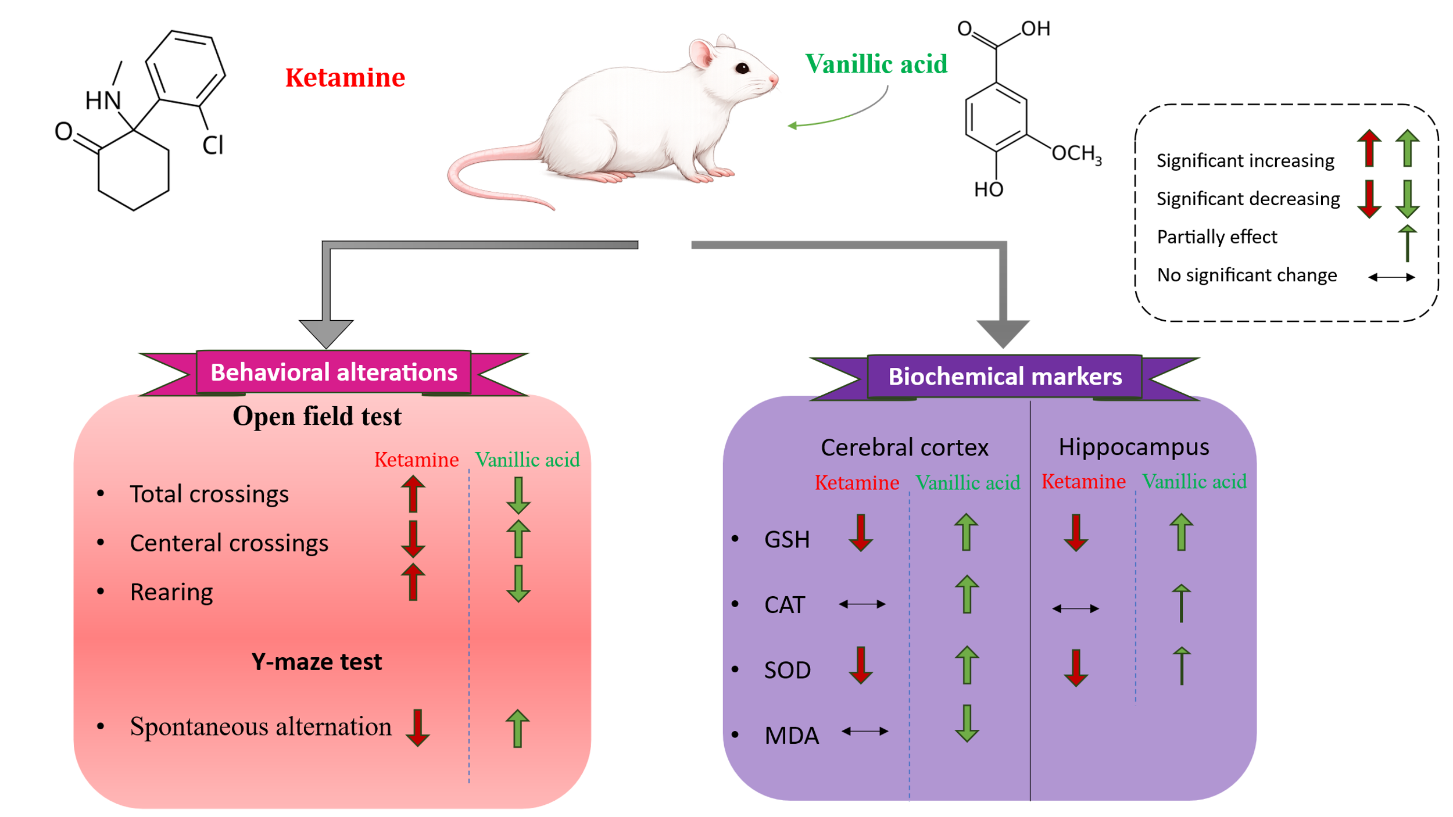
Figure. 6. Schematic illustration of the effects of VA on behavioral and oxidative stress parameters in the KET-induced mania-like behavior model.

