Linagliptin as a Protective Agent
Against Mancozeb-Induced Thyroid Dysfunction: Biochemical and Histopathological Evidence in Rats

Sahar Mostafavi¹, Maryam Shirani², Mehrnoosh Zakerkish*¹,
Sirous Rafiei Asl³, Zahra Farhangian¹

Abstract
Background: Mancozeb (MNZ), a broad-spectrum fungicide, is known to induce oxidative stress and thyroid dysfunction. Linagliptin (Lina), a dipeptidyl peptidase-4 (DPP-4) inhibitor used in diabetes treatment, with antioxidant and anti-inflammatory properties, may offer protection against MNZ-induced thyroid damage. This study aimed to evaluate the protective effects of Lina in combination with MNZ on thyroid function, oxidative stress markers, and histopathology in rats.
Methods: Fifty-four Wistar rats were randomly divided into six groups and treated for six weeks with oral Lina and/or intraperitoneal MNZ, with appropriate controls. Serum levels of thyroid hormones (T3, T4), TSH, and thyroid tissue oxidative stress markers were quantified using ELISA kits. Histopathological changes, including hyperplasia and hypertrophy, were examined. Data were analyzed by one-way ANOVA followed by Tukey’s post-hoc test (p< 0.05).
Results: Mancozeb (MNZ) exposure significantly decreased T3 and T4 levels, increased TSH, elevated malondialdehyde (MDA), and reduced antioxidant enzymes (catalase [CAT], superoxide dismutase [SOD]) and total thiol content. Co-administration of Lina (20 mg/kg) markedly increased antioxidant enzyme activities and total thiol, lowered MDA, improved thyroid hormone profiles, attenuated TSH elevation, and reduced histopathological damage in the thyroid gland. Lower doses of Lina showed limited protective effects.
Conclusion: Mancozeb (MNZ) induces oxidative stress and mild thyroid dysfunction in rats, while Lina exerts protective effects by enhancing antioxidant defenses, restoring hormonal balance, and preserving thyroid tissue structure. These findings suggest Lina’s potential as a therapeutic agent to mitigate thyroid damage caused by oxidative stress-related environmental toxins such as MNZ.

Keywords: Linagliptin, Mancozeb, Oxidative Stress, Protective Agents, Thyroid Gland.

Introduction

The thyroid gland, a vital component of the endocrine system, plays a fundamental role in maintaining metabolic homeostasis through the synthesis and secretion of thyroid

hormones such as thyroxine (T4) and triiodothyronine (T3) (1). Due to its high metabolic activity and significant blood flow, the thyroid is inherently vulnerable to oxidative stress, a condition characterized by an imbalance in favor of reactive oxygen species (ROS) production over cellular antioxidant defenses. Exposure to various environmental and occupational chemical agents, including pesticides and industrial pollutants, can exacerbate this vulnerability and cause oxidative damage in thyroid tissue (2, 3).

Mancozeb (MNZ), a manganese and zinc-based fungicide widely used in agriculture, is effective against fungi but poses potential toxicity risks to non-target organisms (4). Recent toxicological research has confirmed MNZ’s endocrine-disrupting effects. MNZ is partially (50%) but rapidly (3-6 hours) absorbed after a 1.5 mg/kg oral dose, and it is thereafter broadly distributed to tissues, including the thyroid, where it shows the highest radioactivity. According to studies, MNZ affects the pituitary-thyroid axis by reducing the release of thyroid-stimulating hormone (TSH) and thyroid hormones (T3 and T4) (5). MNZ reduces thyroid hormone synthesis or function by directly interacting with nuclear hormone receptors, blocking thyroid peroxidase, and preventing iodine uptake (6). It appears that MNZ's harmful effects are primarily due to the production of ROS, which leads to oxidative stress, lipid peroxidation, mitochondrial dysfunction, and deoxyribonucleic acid (DNA) damage. MNZ metabolites, such as disulfides, disrupt cellular redox balance and induce inflammation, apoptosis, and cellular damage in thyroid tissues. This oxidative damage increases lipid peroxides and DNA lesions, activates inflammatory responses, and exacerbates tissue damage (4, 7).

Given the vulnerability of the thyroid to oxidative stress, finding protective factors to counteract these effects is of considerable scientific and clinical importance. Antioxidants, both endogenously produced and exogenously supplied, serve as vital defenses against ROS. They scavenge free radicals, inhibit lipid peroxidation, and support cellular repair mechanisms to maintain tissue integrity (8, 9). Among these, pharmacological agents with antioxidant properties are being increasingly studied for their potential to protect tissues from environmental and chemical toxins (2, 10).

Linagliptin (Lina), a potent and selective dipeptidyl peptidase-4 inhibitor (DPP-4i) used in managing type 2 diabetes, has been shown to possess significant extra glycemic effects, notably anti-inflammatory and antioxidant actions. Its ability to reduce oxidative stress has been demonstrated in various experimental models, where it enhances endogenous antioxidant enzymes such as superoxide dismutase (SOD) and glutathione peroxidase (GPx), while decreasing levels of oxidative markers such as malondialdehyde (MDA). These effects suggest that Lina can restore redox balance, suppress inflammatory cytokine release, and prevent cellular apoptosis induced by oxidative insults (11-13).

In the context of environmental exposure to oxidative stressors like MNZ, the potential protective effects of Lina could be highly significant. By attenuating ROS production and reducing oxidative damage, Lina may preserve thyroid cell viability, prevent DNA damage, and improve overall tissue function. Investigating this interaction in an experimental setting, such as rat models, could elucidate the molecular mechanisms underpinning these protective effects and provide a foundation for novel therapeutic strategies aimed at safeguarding endocrine organs against environmental toxins. This study aims to explore the capacity of Lina to counteract MNZ-induced oxidative and cellular damage in the rat thyroid gland. Emphasis will be placed on assessing oxidative biomarkers, histopathological alterations, and inflammatory mediators. The findings are anticipated to enhance our understanding of how pharmacological agents with antioxidant properties can serve as protective modulators within vulnerable endocrine tissues subjected to environmental chemical stressors, thereby contributing to safer agricultural practices and environmental health management.

Materials and Methods

Animals

In this experimental study, a total of 54 adult male Wistar rats, weighing between 250 and 300 grams, were obtained from Ahvaz Jundishapur University of Medical Sciences, located in Ahvaz, Iran. The animals were acclimated in polystyrene cages for one week before the start of the experiment. They were maintained under a 12-hour light/dark cycle at a temperature of 22 ± 2°C, with relative humidity maintained between 55% and 65%. Food and water were provided ad libitum. The rats were allowed to adapt to their environment to minimize stress before experimental procedures. All experimental protocols were conducted in accordance with the ethical guidelines for laboratory animal research and received approval from the Ethics Committee of Ahvaz Jundishapur University of Medical Sciences (ethical approval code: IR. AJUMS.ABHC.REC.1402.080).

Drugs and experimental design

Fresh solutions of Lina (Merck, Germany) and MNZ (Sigma Chemicals Co, USA) were prepared at the beginning of each experiment by dissolving the compounds in normal saline.

Grouping and Treatment Protocols

Rats were randomly assigned to six groups, each consisting of 9 animals. The treatment protocols were as follows:
- Control Group: Received no active treatment or exposure, serving as the baseline.
- Lina (20 mg/kg) Group: Administered oral doses of Lina (20 mg/kg) via gavage daily for 21 days.
- MNZ Group: Received intraperitoneal injections of MNZ at a dose of 40 mg/kg, three times per week, totaling 20 injections over six weeks.
- Lina (0.5 mg/kg) + MNZ Group: Received oral Lina at 0.5 mg/kg daily for 21 days, along with intraperitoneal MNZ at 40 mg/kg, three times per week.
- Lina (10 mg/kg) + MNZ Group: Administered oral Lina at 10 mg/kg daily for 21 days, combined with intraperitoneal MNZ at 40 mg/kg, three times per week.
- Lina (20 mg/kg) + MNZ Group: Received oral Lina at 20 mg/kg daily for 21 days, concurrently with intraperitoneal MNZ at 40 mg/kg, three times per week.

All treatments were conducted according to previous studies, optimizing doses for maximal effects on inflammatory and oxidative markers (14, 15).

Sample Collection and Tissue Preparation

Animals were anesthetized with an intraperitoneal injection of ketamine (100 mg/kg) and xylazine (10 mg/kg). Once they were adequately anesthetized, blood samples were collected via cardiac puncture. Following blood collection, the rats were euthanized, and their necks were carefully incised using scissors to extract the thyroid tissue.

Due to the small size of the thyroid gland, blood samples were used to measure systemic antioxidant enzyme activities, including catalase (CAT), and superoxide dismutase (SOD). A portion of each thyroid gland was immediately frozen at -70 °C for subsequent analysis of tissue oxidative stress markers, such as malondialdehyde (MDA) and total thiol content. Another portion was fixed in 10% formalin for histological examination.

Histological Examination of Thyroid Tissue

The formalin-fixed thyroid tissues were routinely processed, embedded in paraffin, and sectioned at a thickness of 5 μm. Tissue sections were stained with hematoxylin and eosin (H&E) to evaluate histopathological changes. The slides were examined under a light microscope, and histopathological findings were documented and scored based on the standard criteria for thyroid tissue alterations (Table 1) (16).

Table 1. Severity grading scheme for follicular cell hyperplasia and follicular cell hypertrophy (11).
Description | Hypertrophy Criterion | Hyperplasia Criterion | Grade
Changes are not significant. | Less than 20% of cells show hypertrophy | Follicular cell hyperplasia affects less than 20% of the tissue | 0
Few changes | 30-50% of follicular cells show hypertrophy | Focal or diffuse crowding of follicular cells affecting 30-50% of the tissue, and/or single papillary or multiple follicular cell layers | 1
Moderate changes | 60-80% of follicular cells show hypertrophy | 60% to 80% of follicles show focal hyperplasia characterized by stratified or pseudostratified follicular epithelium. Papillary depressions may be present | 2
Significant changes | More than 80% of follicular cells show hypertrophy | More than 80% of the follicles show extensive hyperplasia with stratification 2-3 cell layers. Papillary depressions may be present. | 3

CAT Activity

CAT activity in the blood sample was determined using an enzyme-linked immunosorbent assay (ELISA) kit (ZellBio kit, Germany) according to the manufacturer's instructions. The rate of hydrogen peroxide (H₂O₂) decomposition was measured at 570 nm. CAT activity was reported as U/mg of protein.

SOD Activity

The SOD was measured using an SOD activity assay kit (ZellBio kit, Germany) according to the manufacturer’s instructions. In this assay, SOD activity was measured at 420 nm and expressed as U/mg protein.

Total thiol measurement

The total thiol content was detected and measured by the reaction of sulfhydryl groups with Ellman reagent (DTNB) (Sigma-Aldrich, USA) based on the development of a TNB yellow color. One millilitre (ml) of Tris-ethylenediaminetetraacetic acid (EDTA) buffer with pH 8.6 was added to 50 microliters of homogenized tissue and mixed. Then, 20 microliters of 0.01 M Ellman reagent in methanol was added to the mixture, and after 15 minutes of incubation at room temperature, the yellow color formed at a wavelength of 412 nm was read with a spectrophotometer (17).

MDA

Lipid peroxidation of thyroid tissue was assessed by measuring the level of thiobarbituric acid reactive substances (TBARS). These substances, including MDA, react with thiobarbituric acid (TBA) (Merck, Germany) to form a pink-colored complex with a maximum absorption at 532 nm. The procedure is as follows: 3 ml of 1% phosphoric acid and 1 ml of 0.6% TBA were added to 0.5 ml of homogenized tissue, and the mixture was heated at boiling temperature for 45 minutes. After cooling, 4 ml of n-butanol was added and centrifuged at 20,000 rpm for 20 minutes. The organic layer was separated, and its optical absorption was measured at a wavelength of 532 nm (18).

TSH, T4, T3

T3, T4, and TSH concentrations were assessed using a commercial reagent kit (Ez-Test, Australia).

Statistical analysis

Statistical analysis was evaluated using GraphPad Prism 9.0.0 software, applying One-way ANOVA followed by Tukey's post-test. Statistically significant difference between different groups is indicated by *, **, ***, and **** with significance levels, P<0.01, P< 0.05, P< 0.001, P< 0.0001, respectively.

Results

Antioxidant enzyme activities (CAT and SOD) levels

Antioxidant enzyme activities (CAT and SOD) evaluation demonstrates that there is no

statistically significant difference in CAT and SOD activity between the control group and the Lina-only group (Figs. 1 & 2). Conversely, exposure to MNZ significantly decreased CAT and SOD activity compared to the control group (p< 0.01). Additionally, the group receiving both MNZ and the higher dose of Lina (20 mg/kg)

showed a significant increase in CAT and SOD activity relative to the MNZ-only group (p< 0.05 and p< 0.01, respectively).

No significant differences were observed between the MNZ group and the groups receiving combined treatments with MNZ plus Lina at doses of 0.5 mg/kg and 10 mg/kg.

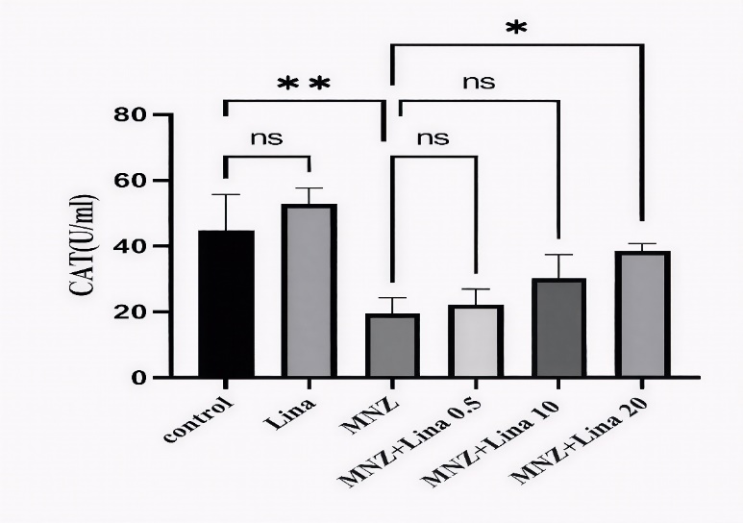
Fig. 1. Effects of Linagliptin on the catalase (CAT) activity in rat serum. Values are means ± SD. Using one-way ANOVA followed by Tukey post-hoc test, (n = 9). *p<0.05 and **p<0.01. MNZ: Mancozeb; Lina: Linagliptin
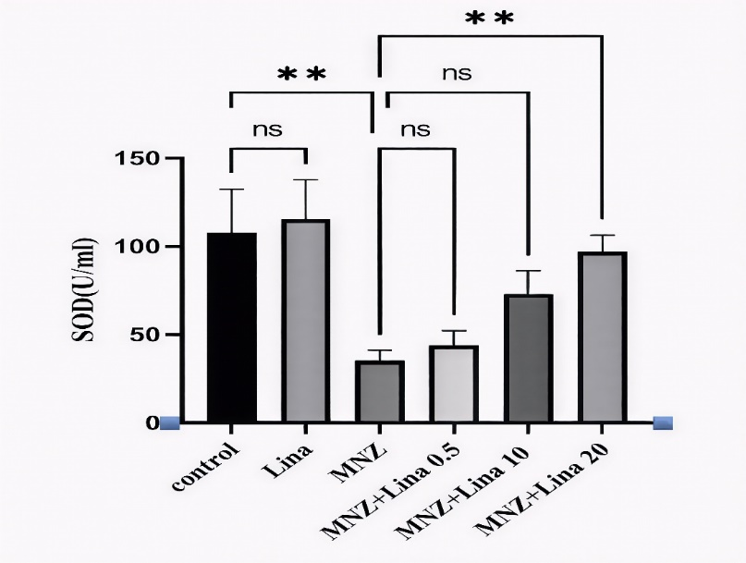
Fig. 2. Effects of Linagliptin on the superoxide dismutase (SOD) activity in rat serum. Values are means ± SD. Using one-way ANOVA followed by Tukey post-hoc test, (n = 9). **p<0.01. MNZ: Mancozeb; Lina: Linagliptin.

Total Thiol Content

The data demonstrate a highly significant reduction in total thiol content in the MNZ-exposed group compared to the control group (p< 0.0001). Furthermore, groups receiving MNZ in combination with Lina at doses of 10 mg/kg and 20 mg/kg showed significantly higher total thiol levels than the MNZ-only group (p< 0.05 and p< 0.01, respectively). No significant differences were observed between the control group and the group receiving Lina alone, nor between the MNZ group and the group treated with MNZ combined with 0.5 mg/kg of Lina (Fig. 3).

MDA Levels

No significant difference was observed in MDA levels between the Lina and control groups (p > 0.05) (Fig. 4). However, a notable elevation in MDA was evident in the MNZ group compared to the control group, indicating increased lipid peroxidation (p< 0.0001). Importantly, administration of Lina at both 10 and 20 mg/kg significantly suppressed MDA levels compared to the MNZ-only group, demonstrating its protective antioxidant effect against MNZ-induced oxidative stress (p< 0.0001).

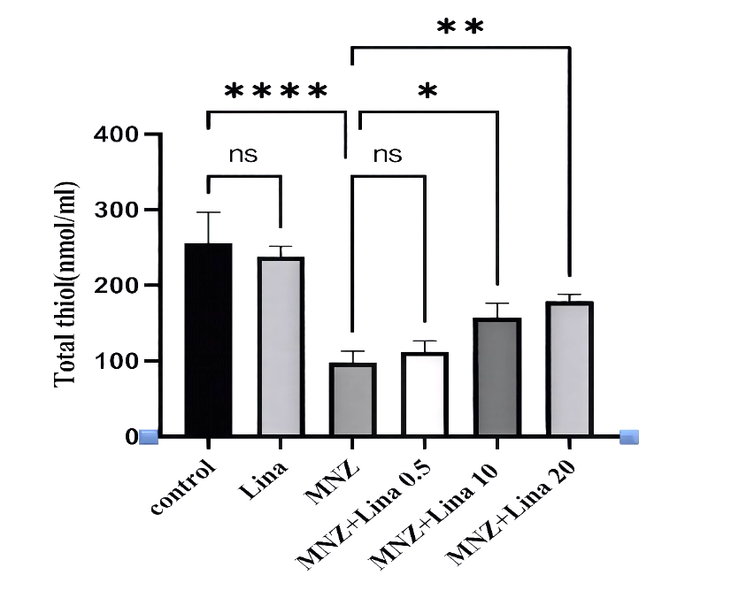Fig. 3. Effects of Linagliptin on the concentrations of Total Thiol in rat thyroid tissue. Values are means ± SD. Using one-way ANOVA followed by Tukey post-hoc test, (n = 9). *p<0.05, **p<0.01, and **** p<0.0001. MNZ: Mancozeb; Lina: Linagliptin.
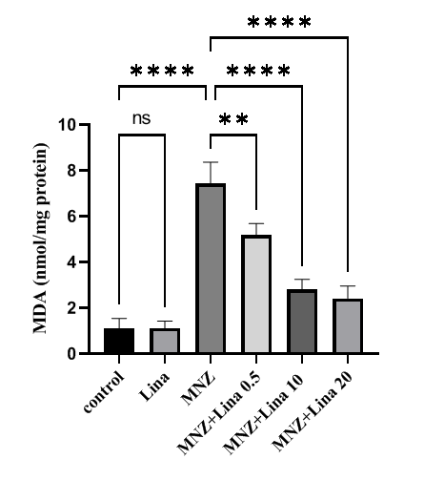
Fig. 4. Effects of Linagliptin on the concentrations of MDA in rat thyroid tissue. Values are means ± SD. Using one-way ANOVA followed by Tukey post-hoc test, (n = 9). **p<0.01, and **** p<0.0001. MNZ: Mancozeb; Lina: Linagliptin.

T3 and T4 Levels

Figure 5 reveals a dramatic decrease in T3 levels in the MNZ group compared to the control group (p< 0.01). The group receiving Lina alone shows no significant change in T3 levels. Notably, when Lina is combined with MNZ, especially at the higher dose of 20 mg/kg, T3 levels gradually increase relative to the MNZ-only group (p< 0.01). Conversely, the groups treated with MNZ combined with Lina at doses of 0.5 mg/kg and 10 mg/kg do not exhibit any significant changes in T3 levels compared to the MNZ-only group.

Treatment with Lina alone does not significantly alter T4 levels (p>0.05) (Fig. 6). Importantly, when Lina is co-administered with MNZ at doses of 10 and 20 mg/kg, there is a notable and statistically significant elevation in T4 levels. However, a lower dose of Lina (0.5 mg/kg) in combination with MNZ does not result in significant restoration of T4 levels.

TSH Levels

The control and Lina groups exhibited comparable TSH levels, with no statistically significant difference between them (p > 0.05) (Fig. 7). In contrast, the MNZ group showed a significant increase in TSH levels compared to the control and Lina groups (p< 0.001). The combined treatments of MNZ with Lina at doses of 10 and 20 mg/kg resulted in a dose-dependent decrease in TSH levels compared to MNZ alone. However, the MNZ + Lina 0.5 mg/kg group did not differ significantly from MNZ alone.

Histological Examination of Thyroid Tissue

The control group and the groups receiving Lina alone show no significant tissue changes, corresponding to Grade 0 (Figs. 8A & 8B, respectively). In contrast, groups treated with MNZ alone exhibit mild
changes, corresponding to Grade 1 (Fig. 8C). The groups receiving combined Lina and MNZ at a dose of 0.5 mg/kg showed similar Grade 1 alterations, indicating mild hyperplasia/hypertrophy (Fig. 8D). Notably,
when Lina is combined with MNZ at doses of 10 and 20 mg/kg, the groups showed no significant tissue changes, corresponding to Grade 0 (Fig. 8E & 8F, respectively).

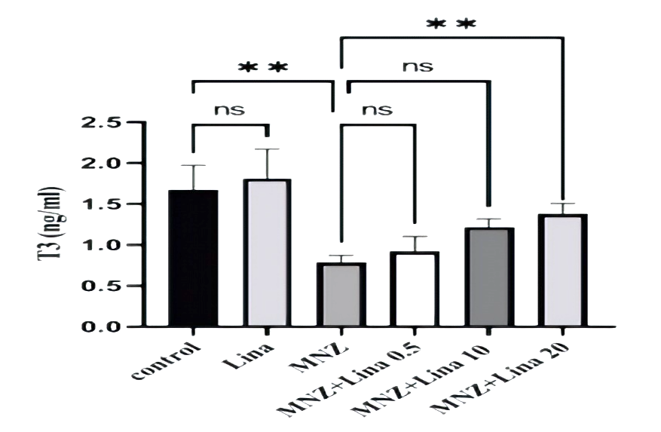
Fig. 5. Effects of Linagliptin on the T3 levels in rat serum. Values are means ± SD. Using one-way ANOVA followed by Tukey post-hoc test, (n = 9). **p<0.01. MNZ: Mancozeb; Lina: Linagliptin.
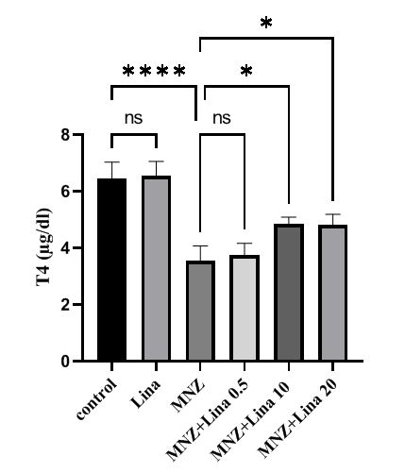
Fig 6. Effects of Linagliptin on the T4 levels in rat serum. Values are means ± SD. Using one-way ANOVA followed by Tukey post-hoc test, (n = 9). ****p<0.0001. MNZ: Mancozeb; Lina: Linagliptin.

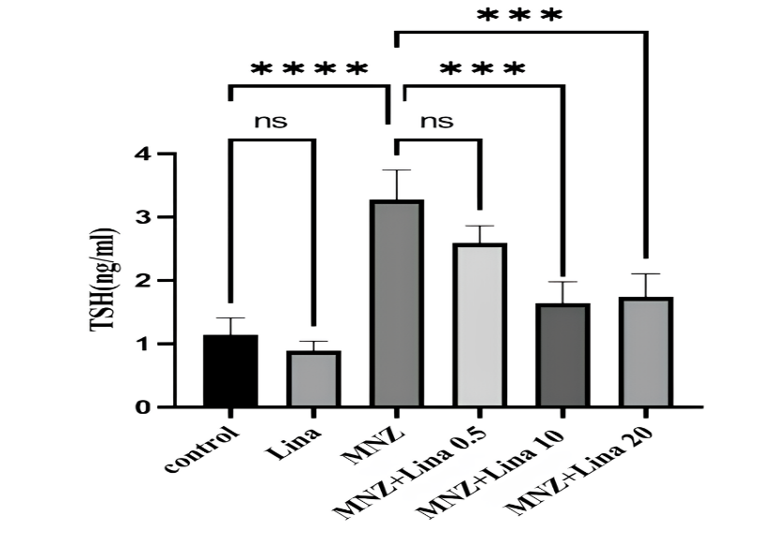

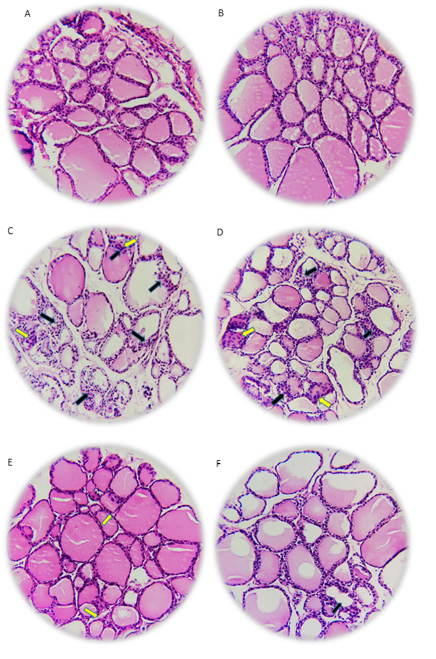

Fig. 7. Effects of Linagliptin on the TSH levels in rat serum. Values are means ± SD. Using one-way ANOVA followed by Tukey post-hoc test, (n = 9). ***p<0.001. MNZ: Mancozeb; Lina: Linagliptin.
Fig. 8. Representative pictures of skin sections stained with hematoxylin and eosin (H&E) examined under a microscope (magnification: ×400). Control Group (A), Lina (20 mg/kg) (B), MNZ Group: (C), Lina (0.5 mg/kg) + MNZ Group (D), Lina (10 mg/kg) + MNZ Group (E), Lina (20 mg/kg) + MNZ Group (F). Hyperplasia of follicular cells (black arrow) and hypertrophy of follicular cells (yellow arrow) are visible (E, D, C, & F).

Discussion

The present study examined the impact of MNZ and Lina on oxidative stress markers, thyroid hormone levels, and thyroid tissue morphology, providing insights into their mechanisms of action and potential protective roles.

The present findings demonstrate that MNZ significantly reduces CAT activity and total thiol content, alongside a decrease in SOD activity, confirming the induction of oxidative stress in thyroid tissue. The diminished activity of these critical antioxidant enzymes, which play essential roles in neutralizing reactive oxygen species (ROS), highlights an increased oxidative burden. Such oxidative stress is consistent with previous studies emphasizing the pivotal role of oxidative stress, characterized by elevated ROS, in mediating tissue damage in thyroid disorders. The reduction in thiol levels, a key component of cellular antioxidant defense, further substantiates the presence of oxidative stress and impaired redox homeostasis, consistent with findings from other research on thyroid pathology (2, 3). Furthermore, ROS exhibit marked reactivity toward various macromolecules, including proteins, DNA, and lipids. The oxidation of polyunsaturated fatty acids leads to the generation of multiple aldehydes with varying carbon chain lengths, such as MDA. Although we did not specifically measure ROS levels in our study, we assessed oxidative stress indirectly by measuring lipid peroxidation, a well-established marker of oxidative damage (19, 20).

Interestingly, co-administration of Lina at higher doses (20 mg/kg) significantly restored CAT activity and elevated SOD levels, underscoring its potential antioxidant properties. This aligns with in vitro and in vivo experimental studies showing that dipeptidyl peptidase-4 inhibitors (DPP4i), including Lina, confer protection against oxidative stress. For instance, Lina has been shown to inhibit ROS production and reduce

inflammation triggered by advanced glycation end products (AGEs) in endothelial and tubular cells, effectively preventing the progression of diabetic renal injury in rat models (21, 22). Similarly, vildagliptin suppresses the RAGE-oxidative stress axis, attenuating vascular damage, while saxagliptin mitigates vascular remodeling and reduces oxidative stress-driven endothelial nitric oxide synthase (eNOS) uncoupling in diabetic mice (23). However, it should be noted that prolonged DPP4 inhibition might lead to adverse effects, such as cardiac fibrosis, in aged, diabetic models fed with high-fat diets, indicating the need for cautious evaluation of long-term therapy (24). The structure of Lina, which is based on a xanthine core, suggests a possible mechanism for its antioxidant activity. Xanthine derivatives are known for their free radical-scavenging ability, which may contribute to the observed protective effects against oxidative stress through direct antioxidant mechanisms or modulation of redox-sensitive pathways (25). Collectively, these findings support the concept that MNZ induces oxidative stress by impairing antioxidant defenses, thereby promoting tissue injury in the thyroid. Conversely, Lina appears to exert protective effects primarily through its antioxidant potential, restoring the redox balance and reducing oxidative damage. These results highlight the therapeutic potential of DPP4 inhibitors like Lina, not only in managing metabolic disturbances in diabetes but also as agents that may mitigate oxidative damage in various tissues.

On the other hand, MNZ significantly suppressed T3 and T4 levels, consistent with its hypothyroid effect reported in earlier studies (4, 26). However, co-treatment with Lina, particularly at doses of 10 and 20 mg/kg, ameliorated these decreases, bringing T3 and T4 concentrations closer to baseline levels. This suggests that Lina may exert a protective effect against MNZ-induced hypothyroidism, possibly through its antioxidant activity,
thereby reducing oxidative damage to thyroid cells. Elevated TSH levels in MNZ-treated groups further support the disruption in thyroid function, while Lina's co-treatment gradually restored TSH levels, indicating a stabilizing effect on the hypothalamic-pituitary-thyroid axis (4, 26).

Histopathological assessment demonstrates that MNZ induces mild hyperplasia and hypertrophy of follicular cells (Grade 1 alterations), signifying a tissue response to damage or stress. Importantly, high-dose Lina co-treatment (10 and 20 mg/kg) did not result in significant tissue changes, suggesting a protective role. These findings corroborate previous reports indicating that antioxidants can mitigate structural alterations in the thyroid gland, potentially preventing the progression to more severe lesions (2, 27).

The observed biochemical and histological data suggest that MNZ induces oxidative stress, disrupting redox balance and impairing thyroid hormone synthesis, which leads to hypothyroidism and tissue hyperplasia. Lina, functioning as an antioxidant, reduces oxidative stress by restoring enzymatic activities (CAT, SOD) and thiol levels, thereby protecting thyroid tissue integrity and hormonal functions. The dose-dependent protective effects of Lina imply that higher doses could be more efficacious in mitigating drug-induced thyroid toxicity.

Although the study provides valuable insights, some limitations include the reliance on serum markers for oxidative stress due to the small size of thyroid tissue, as these markers may not fully reflect tissue-specific dynamics. Further research exploring the molecular pathways involved, as well as longitudinal studies assessing the long-term protective effects of Lina are warranted.

Mancozeb (MNZ) induces oxidative stress and mild thyroid dysfunction in Wistar rats. Linagliptin (Lina), particularly at 20 mg/kg, restores antioxidant defenses, normalizes
thyroid hormones, and protects tissue architecture, showing a clear dose-dependent effect. These results highlight Lina’s potential as a protective agent against thyroid damage caused by oxidative stress-inducing toxins, warranting further studies to explore underlying mechanisms and clinical relevance.

Acknowledgment

This paper is based on Sahar Mostafavi’s thesis for her subspecialist’s degree in endocrinology and metabolism from AJUMS.

Ethics Approval

This study was approved by the Ahvaz Jundishapur University of Medicine’s ethics committee (IR. AJUMS.ABHC.REC.1402.080).

Conflict of interest

There is no conflict of interest

Authors’ Contribution

Mehrnoosh Zakerkish contributed to this research in conceptualization, data curation, formal analysis, funding acquisition, investigation, methodology, project administration, resources, supervision, validation, visualization, writing-review, and editing. Sirous Rafiei Asl contributed to this research in data curation, formal analysis, investigation, methodology, software, supervision, validation, visualization, writing-review, and editing. Maryam Shirani contributed to this research in data curation, formal analysis, investigation, methodology, resources, software, supervision, validation, visualization, and writing-original draft. Zahra Farhangian contributed to this research in formal analysis, investigation. Sahar Mostafavi contributed to this research by formal analysis, investigation, methodology, software, validation, visualization, and writing- original draft.

References
- Al-Suhaimi EA, Khan FA. Thyroid glands: Physiology and structure. Emerging concepts in endocrine structure and functions. Springer. 2022;Ch 1:133-60.
- Macvanin MT, Gluvic Z, Zafirovic S, Gao X, Essack M, Isenovic ER. The protective role of nutritional antioxidants against oxidative stress in thyroid disorders. Front Endocrinol. 2023;13:1092837.
- Kochman J, Jakubczyk K, Bargiel P, Janda-Milczarek K. The Influence of Oxidative Stress on Thyroid Diseases. Antioxidants (Basel). 2021;10(9):1442.
- Mohanty B. Mancozeb exposure disrupts endocrine function of the ovary and thyroid in Red Munia (Amandava amandava). Chemosphere. 2025;374:144202.
- Kackar R, Srivastava MK, Raizada RB. Studies on rat thyroid after oral administration of mancozeb: morphological and biochemical evaluations. J Appl Toxicol. 1997;17(6):369-75.
- Ksheerasagar RL, Kaliwal BB. Temporal effects of mancozeb on testes, accessory reproductive organs and biochemical constituents in albino mice. Environ Toxicol Pharmacol. 2003;15(1):9-17.
- Zhang Y, Wen R, Bao J, Gong Y, Wang X. Mancozeb induces nephrotoxicity by impairing the oxidative phosphorylation pathway: A transcriptome study. Ecotoxicol Environ Saf. 2023;249:114471.
- Shirani K, Behravan J, Mosaffa F, Iranshahi M, Mehmankhah B, Razavi-Azarkhiavi K, Karimi G. Evaluating the effects of galbanic acid on hydrogen peroxide-induced oxidative DNA damage in human lymphocytes. Avicenna J Phytomed. 2014;4(5):337-42.
- Badiee MS, Vadizadeh A, Salehcheh M, Moosavi M, Shirani M, Fakhredini F, Khodayar MJ. Quercetin and Catechin Protects Leptin-Deficient Lep^{ob/Ob} Mice Against Alloxan-Induced Diabetes and Hepatotoxicity via Suppression of Oxidative Stress and Inflammation. Rep Biochem Mol Biol. 2024;13(2):184-195.
- Chakrabarti SK, Ghosh S, Banerjee S, Mukherjee S, Chowdhury S. Oxidative stress in hypothyroid patients and the role of antioxidant supplementation. Indian J Endocrinol Metab. 2016;20(5):674-678.
- Grim KC, Wolfe M, Braunbeck T, Iguchi T, Ohta Y, Tooi O, et al. Thyroid histopathology assessments for the amphibian metamorphosis assay to detect thyroid-active substances. Toxicol Pathol. 2009;37(4):415-24.
- Kawanami D, Takashi Y, Takahashi H, Motonaga R, Tanabe M. Renoprotective Effects of DPP-4 Inhibitors. Antioxidants (Basel). 2021;10(2):246.
- Makino H, Matsuo M, Hishida A, Koezuka R, Tochiya M, Ohata Y, et al. Effect of linagliptin on oxidative stress markers in patients with type 2 diabetes: a pilot study. Diabetol Int. 2018;10(2):148-152.
- Morales-Ovalles Y, Miranda-Contreras L, Peña-Contreras Z, Dávila-Vera D, Balza-Quintero A, Sánchez-Gil B, Mendoza-Briceño RV. Developmental exposure to mancozeb induced neurochemical and morphological alterations in adult male mouse hypothalamus. Environ Toxicol Pharmacol. 2018;64:139-146.
- Abhangi KV, Patel JI. Neuroprotective effects of linagliptin in a rotenone-induced rat model of Parkinson's disease. Indian J Pharmacol. 2022;54(1):46-50.
- Karimi S, Koohpeyma F, Khorsandi L, Panahi A, Rezaei-Tazangi F, Fakhredini F. Comparative Analysis of Curcumin and Metformin Effects on the Kidney in a Model of Unilateral Nephrectomy and Ischemia-Reperfusion Injury. Rep Biochem Mol Biol. 2025;13(4):579-589.
- Hewawasam R, Jayatilaka K. Antioxidant effect of crude water extract of Vetiveria zizanioides (Gramineae) in mice with acetaminophen induced hepatotoxicity. Int J Pharmacognosy. 2015; 3:11-20.
- Amarowicz R, Estrella I, Hernández T, Robredo S, Troszyńska A, Kosińska A, Pegg RB. Free radical-scavenging capacity, antioxidant activity, and phenolic composition of green lentil (Lens culinaris). Food chem. 2010;121(3):705-11.
- Shariati S, Khodayar MJ, Azadnasab R, Nooshabadi MR, Nikravesh M, Khorsandi L, et al. Epicatechin as a promising agent against arsenic-induced neurobehavioral toxicity in NMRI mice: behavioral and biochemical alterations. Naunyn Schmiedebergs Arch Pharmacol. 2024;397(12):10143-10153.
- Shariati S, Khodayar MJ, Azadnasab R, Moghtadaei N, Khorsandi L, Shirani M. Protective Effects of Vanillic Acid on Arsenic-Induced Hepatotoxicity and Diabetes in Mice; the Role of PPARγ and NF-κB Signaling. Rep Biochem Mol Biol. 2025;13(4):549-560.
- Kaifu K, Ueda S, Nakamura N, Matsui T, Yamada-Obara N, Ando R, Kaida Y, et al. Advanced glycation end products evoke inflammatory reactions in proximal tubular cells via autocrine production of dipeptidyl peptidase-4. Microvasc Res. 2018;120:90-93.
- Ishibashi Y, Matsui T, Maeda S, Higashimoto Y, Yamagishi S. Advanced glycation end products evoke endothelial cell damage by stimulating soluble dipeptidyl peptidase-4 production and its interaction with mannose 6-phosphate/insulin-like growth factor II receptor. Cardiovasc Diabetol. 2013;12:125.
- Maeda S, Matsui T, Yamagishi S. Vildagliptin inhibits oxidative stress and vascular damage in streptozotocin-induced diabetic rats. Int J Cardiol. 2012;158(1):171-3.
- Mulvihill EE, Varin EM, Ussher JR, Campbell JE, Bang KW, Abdullah T, et al. Inhibition of Dipeptidyl Peptidase-4 Impairs Ventricular Function and Promotes Cardiac Fibrosis in High Fat-Fed Diabetic Mice. Diabetes. 2016;65(3):742-54.
- Shiheido-Watanabe Y, Maejima Y, Kasama T, Tamura N, Nakagama S, Ito Y, et al. Linagliptin, A Xanthine-Based Dipeptidyl Peptidase-4 Inhibitor, Ameliorates Experimental Autoimmune Myocarditis. JACC Basic Transl Sci. 2021;6(6):527-542.
- Kwon D, Chung HK, Shin WS, Park YS, Kwon SC, Song JS, Park BG. Toxicological evaluation of dithiocarbamate fungicide mancozeb on the endocrine functions in male rats. Mol Cell Toxicol. 2018;14(1):105-12.
- Paunkov A, Chartoumpekis DV, Ziros PG, Chondrogianni N, Kensler TW, Sykiotis GP. Impact of Antioxidant Natural Compounds on the Thyroid Gland and Implication of the Keap1/Nrf2 Signaling Pathway. Curr Pharm Des. 2019;25(16):1828-1846.

